**Baseline variability drives heterogeneity in prebiotic-induced ecological dynamics of gut microbiota and short-chain fatty acids**

**Abstract.** The end-point responses of prebiotic fiber intervention are highly individualized and their associations with pretreatment gut microbiota have been previously reported. The missing links between baseline microbiota and end-piont heterogeneity are the community dynamics, yet the temporal patterns and ecological processes driving the community responses remain poorly understood. Here we administered inulin and resistant starch from maize to adult mice that carry distinct microbiota and monitored the dynamics of microbiome profiles and short-chain fatty acids (SCFAs) over four weeks. We found that inulin is more capable of stimulating production of SCFAs than resistant starch. Inulin induced biphasic changes in SCFAs concentration and microbiota biodiversity, both of which were quickly perturbed in the short-term but only partially recovered even under sustainable inulin supply. We further identified a consortium of five inulin responders that collectively shape short-term microbiota dynamics through an activation-then-competition mechanism. The obsevered dynamical responses depend on baseline microbiota and the baseline-dependency was found in 10%-20% bacterial species and the majority of SCFAs. In accordance with previous human studies, the baseline-sepcific feature poses a great challenge to extrapolate prediction of SCFA concentration from gut microbiota to unobserved baseline composition. Our study reveals time- and baseline-dependency of dietary fiber responses as major challenges for attainable and robust personalized nutritional therapies.

Keywords: mouse, dietary fiber intervention, gut microbiome, time-series, dynamics, short-chain fatty acids, ecological network, biphasic responses, inulin, resistant starch

**Introduction**

# Dietary intervention is a safer way of restoring normal gut microbiota function

The human gut microbiome is a complex ecosystem of hundreds of trillions of tiny microbes (bacteria, fungi, virus, etc.) that co-evolves with us in the gastrointestinal tract. Prebiotic fibers (e.g., inulin and resistant starches) are often used as an intervention on gut microbiota to promote production of short-chain fatty acids (SCFAs), which regulate the host immune system and intestinal homeostasis. Impaired intestinal SCFAs production has been significantly associated with several metabolic diseases (e.g., type 2 diabetes mellitus, obesity and inflammatory bowel disorders) [2], chronic Graft-versus-host-disease, and efficacy of immunotherapy for solid tumors [3].

Encouraged by the success of using fecal microbiota transplant (FMT) as a therapy to treat recurrent Clostridium difficile infection, new microbiome therapies aiming to alter compositions of gut microbiota [4,5,6] have been increasingly developed and tested to restore dysbiosis. The two major non-invasive strategies are dietary [7] and pharmacological modulations, with the former much safer intervention that lowers the risk of bacterial resistance and prevents antibiotic overuse.

By interacting with host cells, near or far from the GI tract, the normal gut microbiota has profoundly influenced various human physiological processes by assisting human nutrient and drug metabolism, modulating immune responses, and protecting against pathogen invasion and infections [1]. Although the gut microbiota remains stable in its composition and function over months and possinbly years, disruption of its ecological balance (dysbiosis) has been linked to many human illnesses. For instance,

# The interactions between diet, gut bacteria and SCFA metabolism is partially known

Despite a long history of using prebiotics to promote healthy digestive tract and immune system, the efficacy of dietary therapy has been less validated due to the complex interplay between diet, gut microbiome and host health. The most straightforward goal of dietary intervention is to boost growth of “healthy” bacteria, even though a consensus definition of “healthy micrbiome” is lacking. Depending on the avaiablity of fermentable fibers in the gut, gut microbes choose between those fibers and other energetically less favaroable sources (e.g., amino acids) to regulate the fatty acid composition, where the former sources produce SCFAs are the mojor end products. SCFAs, especially butyrate, have broad impacts on human host physiology by acting as histone deacetylases inhibitors, ligands of G-protein-coupled-receptors, and energy sources for the colonocytes and other host tissues. However, supplementation of dietary fiber to selectively stimulate and enrich SCFA producers is not as straightforward as it sounds: gut microbiome as an ecosystem exihibits community-level, rather than individual-level, responses. The microbial conversion from dietary fiber to SCFAs involve a number of cascading events, specific members of the gut microbiota, and diverse ecological interactions between these members. In a classical paradiagm, complex polysaccharides are first hydrolyzed by primary fiber-degrading bacteria like Bacteorides. These primary degraders can either produce SCFAs themselves or fuel the fermentation pathway of secondary degrader bacteria by releasing a wide range of accessible carbohydrates (e.g., mono- or oligo-saccharides) [10, 11].

Ecological diversity and interindividual variatiy are two hallmarks of healthy gut microbiome.

# Dietary intervention often leads to heterogenous responses and two main sources are dynamics and baseline microbiota composition

Although it has been firmly demonstrated that diets can alter gut microbiota composition and SCFAs [4], the changes are highly variable among human recipients [14]. For example, Baxter et al. shows that inulin was able to promote butyrate production in only 63% healthy young adults. Although host differences (e.g, age, sex) has been associated with dietary responses, there is growing evidences that the temporal dynamics and pretreatment gut microbiota composition are two major independent sources of the observed heterogeneity. It has been previously shown that dietary fibers are able to quickly alter gut microbiota diversity and composition on the timescale of a day regardless of the baseline microbiota. For example, Creswell et al. showed that high-dose inulin-type fructans induced similar temporal trends with significantly decreased biodiversity across 8 human participants with substantial cross-subject differences in their pretreatment gut microbiota structure. Despite these invaluable studies, the literature has extensively focused on cross-sectional data and the dynamical patterns of dietary responses in gut microbiota and SCFAs remain poorly understood. On the other hand, the presence and abundance of dietary fiber degraders and other functional group among individuals prior to dietary fiber supplementation could also lead to personalized outcomes [17]. Metabolic specialization and niche partitioining commonly occur in the human gut: microbes can rarely metabolize a wide range of fibers all with high specificity [15, 16] or secrete a diverse array of metabolites all with high productivity. As such, the baseline composition is a priming factor for the underlying ecological and metabolic processes that affect microbial responses to dietary fiber. To improve the clinical efficacy of dietary fiber interventions with rational design of personalized nutritional intervention regimens, it is critical to understand how gut microbiome changes in composition and metabolism over time, identify the putative consortia of fiber responders from the pretreatment gut community, and dissect the ecological interactions among these key members that drive the temporal patterns and long-term responses.

# Our approach to meet the challenges

Compared to antibiotics which can severely disrupt gut microbiota and lead to expansion and domination of facultative anaerobes (e.g., Vancomycin-resistant Enterococcus) in the gut, diet as a modifiable factor is much milder and its effects may be statistically berried among counfinding variables in clinical trials. Studying dietary effects on gut microbiota using mouse models, as a complimentary alternative to clinical trials, has better controls over confounding variations between individuals driven by environmental and other host differences. For this purpose, we purchased age- and gender-matched isogenic C57BL/6J mice that harbor dinstinct gut microbiota composition from four commercial vendors (independent breeder sources), mimicking the efforts of stratifying human subjects into groups based on their gut microbiota to tackle the individuality issue in personalized nutriention. By collecting stool specimens over an experimental period of 4 weeks, we continuously monitored temporal shifts in absolute abundances of fecal bacteria (16S rRNA gene sequencing and quantitative PCR), gene abundances (metagenomics sequencing), SCFAs concentration (targeted metabolome) as well as physiological changes of treated mice (e.g., body weight) following intervention of two high fermentable fibers (inulin and resistant starch from maize) and a low fermentable cellulose control (Fig 1A). Both inulin and resistant starch are resistant to hydrolysis by human enzymes in the upper gut and known to be degraded by gut bacteria in the cecum and colon [18][19]. Motivated by a central hypothesis that heterogenous responses of gut microbiota and SCFAs are primed by pretreatment micriobioal community structure and diet-associated ecology (Fig. 1B), we developed several computational approaches to address different aspects (quantifications, causes and consequances) of the diet-induced heterogeneity.

**Results**

**Baseline characteristics of the murine microbiome**. As expected, th

e baseline gut microbiota has more similar bacterial composition across mice within the same vendor than mice between different vendors (Fig. 1C,D), despite they were genetically identical and co-housed in the same cages and fed with the same cellulose-based diet 7 days prior to dietary fiber intervention. Beta-diversity (between-sample distance), calculated by the Aitchison distance at the lowest classified taxonomy level, shows that the baseline gut microbiota of our mice cluster by vendor (Adonis, P<0.001) and are characterized by distinct bacterial taxa (Fig. 1C). For example, Shanghai mice lack several commensal mucosal-monosaccharide-utilizers such as Muribaculaceae and Rikenellaceae. The profound intervendor difference (Adonis, P<0.001) has also been observed at higher taxonomic levels (family and phylum). Since the between-vendor variance is much larger, mice from the same vendor can be effectively treated as independent biological replicates for each baseline microbiota condition.

While difficult to stratify human microbiomes, these mice divided by vendor sources form distinct groups of baseline microbiota composition.

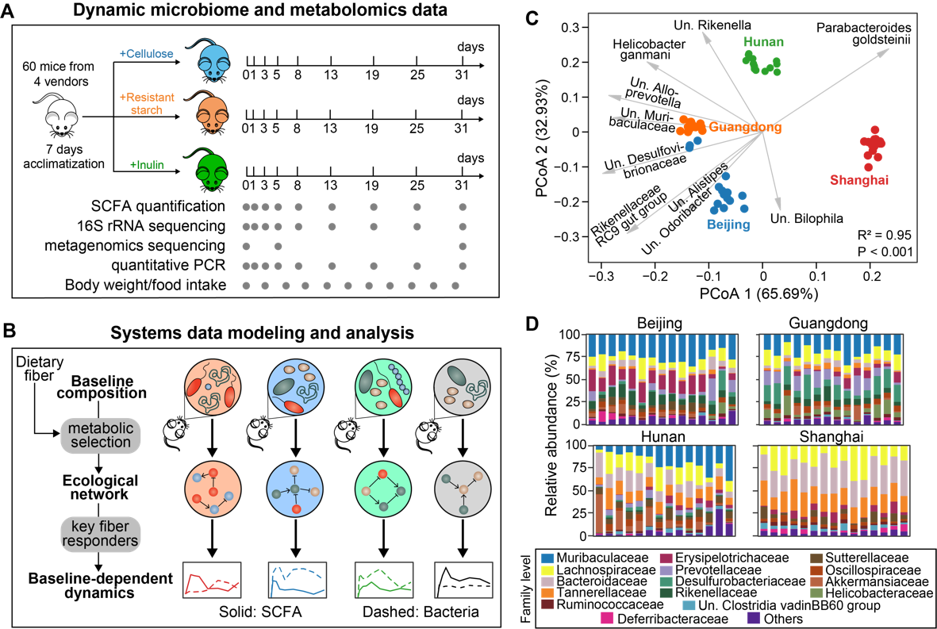

**Figure 1.** **Experimental design and computational framework for this study. A.** Schematics of the experiments performed on a mouse model. Gray dots indicate the days on which longitudinal fecal samples, microbiome and metabolomics data were collected. SCFA: short-chain fatty acid. **B.** An ecology-centric view of baseline-dependent dynamical fiber responses. We used mathematical modeling to infer ecological network under diet selection and key fiber responders that determine baseline dependency of both microbiome and SCFA dynamics. **C**. PCoA (principal coordinate analysis) plot of beta diversity of baseline microbiota composition of isogenic mice purchased from four different vendors (Beijing, Guangdong, Hunan and Shanghai). Dots represent baseline samples and gray arrows represent dominant bacterial species in the samples. The sample whose dot projects furthest in the direction of a species has the highest relative abundance of that species. R2 and P-value were obtained from Adonis analysis, which tests for baseline differences across the four vendors. T**D**.The bat family level.

**Biphasic dynamics of SCFAs and gut biodiveristy**. Dietary intake of inulin and resistant starch increases mice body weight gradually over time but the amount of body weight gain is generally insignificant compared to mice treated with the cellulose control (Fig. S1A). Although there were no obvious temporal patterns in the fiber intake rate (Fig. S1B,C) and fecal weight (Fig. S1D), the fecal weight was dramatically lower in inulin- and resistant starch-fed mice, suggesting increased colonic transition time. Accordingly, the intestinal absorption of both fermentable fibers by gut microbiota promoted fecal SCFA production (Fig. 2A). Consistent with previous human studies, inulin stimulated higher production of total and three major individual SCFAs (acetate, propionate, and butyrate) than resistant starch regardless of baseline microbiota (Fig. 2A and S2). Still, the quantitative differences in the stimulating effects of inulin and resistant starch are SCFA- and baseline-dependent.

The inulin-induced changes in fecal SCFA concentration follow biphasic dynamics: their levels peaked in short-term before gradually decreasing until steady states. Depending on the baselilne microbiota, the mean (time-average) final level of total SCFA at day 31 is 60%-65% of its peak but 2.0-3.5 times as high as its baseline level at day 0. The long-term decrease in fecal SCFA concentration was not a result of reduced diet intake as the intake rate remains largely unchanged over time (Fig. S1B,C). Since fecal SCFAs are metabolites produced by colonic bacterial fermentation of dietary fibers, we observed similar biphasic, but undershoot, inulin-induced dynamics in the gut biodiversity, which drops initially before gradual increase (Fig. 2B). Concordantly, we observed complex, non-monotonic changes in the relative abundance of several dominant bacterial taxa such as Bacteroides and unclassified Muribaculaceae (Fig. 2C). Similar to SCFA dynamics, the trends of biodiversity are qualitatively consistant but quantitatively different across the four baseline microbiota conditions. We further showed that the undershoot dynamics of biodiversity was largely caused by the changes in evenness (Fig. S3A), rather than richness (Fig. S3B), suggesting ecological expansion and dominance of certain inulin responders from baseline communities. Supporting these findings, metagenomic sequencing revealed that the initial (day 0), short (day 5)- and long (day 31)-term microbiomes have distinct gene family profiles and functions (Fig. 2D). However, there were no consistent time-dependent patterns of SCFAs and gut microbiota biodiversity induced by resistant starch.

**Convergent adaptation of gut microbiota composition.** Both extrinsic factors (e.g., nutrient availability) and intrinsic factors (e.g., baseline microbiota) shape microbiota composition and its dynamical responses under environmental perturbation. Since environment selects for adaptations that augment bacterial nutrient acquision and growth, we hypothesized that dietary fiber promotes convergence of baseline microbiota towards similar composition. Fig. 2E shows the temporal changes in between-vendor similarity of gut microbiota composition. All three dietary fibers, including cellulose (control), reduced baseline microbiota differences by ~35% at day 31 after transient fluctuations. Such convergent adaptations are evident in the dynamics of some dominant taxa. For example, the relative abundance of the unclassified Muribaculaceae in the Shanghai mice was initially much lower at day 0 but finally reached similar levels as in the mice from the other three vendors at day 31.

We also found strong tendency for bacterial community stimulated by inulin (Fig. 2F), and to less degree by resistant starch (Fig. SX), to reach long-term equilibria in compositions. Regardless of the vendors, the steady-state compositions at day 31 are distinct from their baseline counterparts for both fibers and thus represent new equilibria sustained by dietary fiber intake. Specificially, the gut microbiota in Gunagdong mice almost returned to its original compositionand is thus more resilient to perturbations. `To quantify the rate of convergence to the equilibria, we fit the harmonic oscillator model from physics to the biodiversity—a summary statistic of sample composition, and calculated damping ratio—a dimensioness measure of whether and how a dynamical system approaches steady states under perturbations— from the best-fit parameters (see Methods). The model fits the data reasonally well for inulin-fed mice (mean R2 of ~60%) but had a poor performance for resistant-starch-fed mice (mean R2 of ~30%). For inulin-fed mice, the damping ratios are equal or greater than 1, meaning that their responses were critically or overdamped and no oscillations were involved in the responses. The oscillation-free property is critical for ecosystems to maintain dynamic stability and integrity during adaptation. Although the damping ratio varies among individual mice, the dynamical responses of ~50% mice were critically damping (damping ratio close to 1) which leads to the fastest convergence towards stationary equilibria. More interestingly, the critical damping behavior was also found in human gut microboime recovery after transient antibiotic exposure, suggesting that it may be an intrinsic dynamic property of gut microbial communities.

corroborate our on the inulin-induced dynamical responseswith similar experimantal setup, whichalso profiled the gut based on 16S rRNA sequencing Their data independently showed undershoot dynamics of biodiversity and its tendency to converge after 14 days(Fig. S4). The reproducibility of our observations also suggests that the characteristic responses of gut microbiota to inulin intervention is primarily driven by ecological inner-workings (systems property) and less dependent on the baseline composition (initial condition).

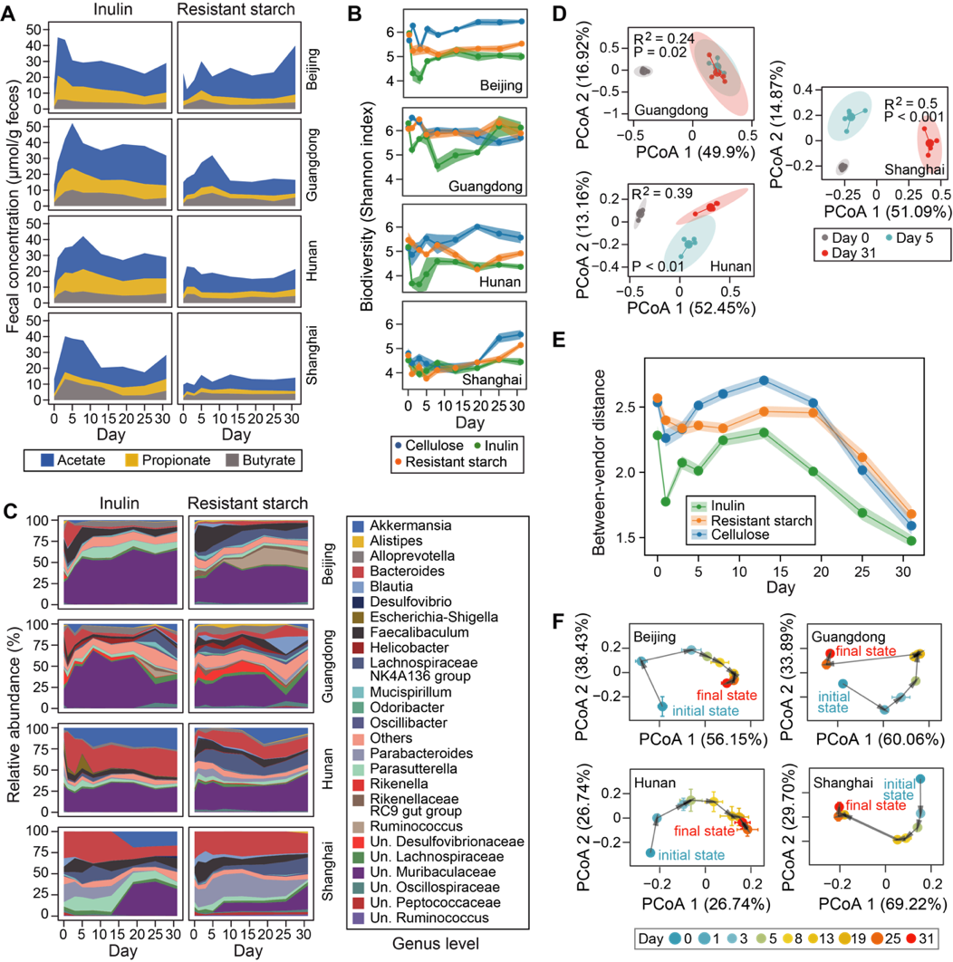

**Figure 2.** **Dynamical responses of short-chain fatty acid (SCFA) metabolism and murine gut microbiome to dietary fiber intervention. A**-**C.** Temporal changes in fecal concentration of three major SCFAs (A), microbiota alpha diversity (B), and gene family abundances of mice gut metagenome (C) during four weeks’ dietary fiber intervention. Both SCFA concentration and microbiota diversity show short-term overshoot and long-term steady-state responses to inulin treatment. For panel B, taxonomic labels w/ “Un.” group bacteria that are unclassified or uncultured at lower taxonomic ranks. For panel C, R2 and P-value were obtained from Adonis analysis, which tests for the difference in gene abundances during intervention (day 0: baseline, day 5: short-term response, day 31: long-term response). **D**,**E.** The response trajectories of gut microbiota composition to inulin as well as their PCoA (principal coordinate analysis) plots (E) indicate compositional transition and convergence to a new steady state. **F**. Total bacterial density measured by quantitative PCR. **T**he heights of stacked bands (panels A, D), lines (panel B, F) or dots (panel E) represent the mean values across mice within the same vendor and shading areas (panel B, F) or error bars (panel E) represent standard error of the mean.

**Inferring dietary fiber responders.** A number of culturable bacteria could metabolize inulin and resistant starch *in vitro* but an *in vivo* understanding of the bacterial fiber degraders and the ecology correlated with their fermentation has not been established yet. Since genomic approaches rely on strain-level identifiability and culturability, we switched to a data-driven approach that aims to identify responders that can directly or indirectly metabolize dietary fibers. If such responders exist, we would expect increased abundance of their populations with a concomitant higher level of enzymes capable of fiber degradation following treatment. Indeed, the relative abundance of genes encoding inulinase significantly increased from day 0 to day 5 and/or day 31 (Fig. 3A), suggesting that inulinase may be a metabolic trait that has been selected for by inulin.

To infer dietary fiber responders from the complex microbiota, we employed the generalized Lotka–Volterra (gLV) equation to model the observed dynamical responses. The gLV model phenonmenlogically summarizes the underlying ecology by three terms that additively determine bacterial growth rates (Fig. 3B): the basal growth rates (), the influences from other bacteria (), and the impacts of environement (). In this study, represents the growth responses of bacteria to dietary fiber. To estimate the uncertainties associated with these parameters, we further formulated the inference problem in a Bayesian framework (see Methods). Positive or negative responders are defined as those bacteria whose 95% credible interval of the posterior distribution of is completely to the right or left of 0. Since gLV models the absolute abundance of bacterial taxa, we measured the fecal bacterial density of each sample by quantitative PCR (Fig. 3C and Fig. SX) and then multiplied the density by their relative abundance to calculate absolute abundance. Except for the Shanghai group, inulin nourished gut microbes by rapidly (in a day) boosting their density to more than 70% of carrying capacity (maximum bacterial load sustained by dietary fiber intake).

Using longitudinal data from all mice, the above-mentioned approach identified five (all positive) inulin responders at different taxonomic levels (Fig. 3D): Bacteroides acidifaciens (speices), unclassified Muribaculaceae (family), unclassified Faecalibaculum (genus), unclassified Parasutterella (genus), and unclassified Bacteroides (genus). Since gLV incorporates bacterial interactions (e.g., cross-feeding) as confounding variables, these responders are mostly likely to be primary inulin degraders. In fact, genetic and/or *in vitro* evidences have been found to support the role of these responders (expect for unclassified Parasutterella) in degrading inulin (Table X). For example, members from Bacteroides and Muribaculaceae harbor gene clusters known as polysaccharide utilization loci (PULs), which contain *C/sus*homologous gene pair that facilitates sensing and import ofinulinthe assembled from metagnomics data . Confirmedly, Bacteorides acidifaciens was also predicted to be a positive inulin responder when applying our approach to relative abundance data from an orthogonal inulin intervention study. We found singifincat association between the total relative abundance of the five inulin responders and the absolute abundance (P < 0.001). For resistant starch, three (all positive) responders (Fig. SX)—unclassified Faecalibaculum (genus), muribaculaceae (genus), and unclassified Desulfovibrionaceae (genus)—were inferred and all have been implicated in utilizing resistant starch from literature (Table S3).

**Inulin responders as a functional guild shape microbiota dynamics.** There is increasing evidences that ecological guilds (groups of bacteria that perform similar ecological functions), rather than taxonomic groups, are the fundemantal units for microbiome data analysis. In line with the guild-based concept, the inferred responders, though taxonomically heterogenous, define a core group that participates in dietary fiber degradation. By coarse-graining and partitioning microbiota dynamics between responders and the rest bacteria, we showed that the total relative (Fig. SX) and absolute (Fig. 3D) abundances of the inulin responders dominate the responses of the entire microbiota in short-term (Guangdong, Hunan), long-term (Shanghai), or even the entire period of observation (Beijing). In Hunan mice, the total biomass of the rest bacteria did not respond to inulin for the first few days but then increased gradually until reaching similar levels to the responders. More interestingly, the dynamics of the two guilds co-oscillated and became tightly linked afterwards. Consistent with a previous finding that delayed succession of bacterial blooms of secondary degraders compared to primary degraders [12], it is likely that the rest bacteria are composed of taxa (mainly Akkermansia mubnicipila and Bacteroides unifomirs) that utilized simple sugars realeased from primary inulin degraders through cross-feeding mechanism. This also explains the second peak in total bacteria density in Hunan mice (Fig. 3C): the rest bacteria occupied new ecological niche created by primary inulin degraders and increased carrying capacity further beyond the level set by inulin (first peak).

Additionally, there is also substantial heterogeneity in the dynamical responses among the five inulin responders (Fig. 3F, SXA). Bacteroides acidifaciens and unclassified Facelibaculum showed transient dyanmcis with quick rise and drop in their relative or absolute abundances, which correspond to and may explain the undershoot dynamics of biodiversity (Fig. 2B). By constrast, the relative or absolute abundances of unclassified Muribaculaceae increased continuously and remained high level through the entire period of observation. Since the total bacterial density reached plateau rapidly (Fig. 3C), the inulin responders started to compete for inulin after the gut microbiota has reached its carrying capacity. The internal competition was supported by the gLV-based inference of bacterial interactions (Fig. 3F), where unclassified Muribaculaceae negatively influenced the growth of Bacteroides acidifaciens and unclassified Facaelibaculum (highlighted in red). Compared to inulin, the guild of resistant starch responders is much less well defined and became predominant only in Beijing mice (Fig. SX). One possibility is that there are more mild and vendor-specific responders to resistant starch than to inulin such that they did not pass the significance tests of a 95% credible interval. Nonetheless, we found similar dynamics of unclassified Muribaculaceae (increase and level off) and unclassified Facaelibaculum (quick rise and drop), and a mutual inhibition was inferred to drive the observed dynamics (Fig. SX). The competitative advantage of Muribaculaceae was also reported in mice treated with acarbose, suggesting metabolic versatility of the family Muribaculaceae.

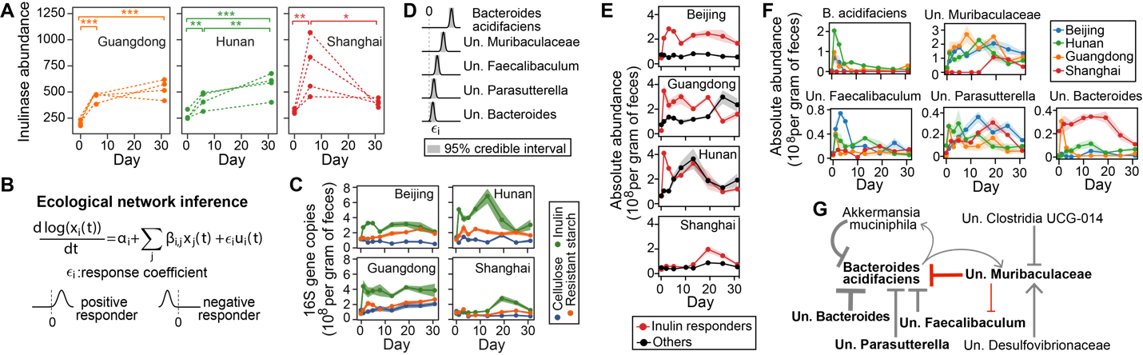

**Figure 3. Microbiota dynamics in response to inulin is driven by several key** **responders****. A.** Increased expression of inulinase genes following inulin treatment. Each dotted line represents an individual mouse. *: P < 0.05; **: P < 0.01; ***: P < 0.001. **B**. Generalized Lotka-Volterra model combined with Bayesian statistics to infer inulin responders and associated ecological interactions. **C.** Posterior distribution of five bacterial species with significant growth responses. **D**,**E**. The total (D) and individual (E) absolute abundance of five inulin responders shown in panel C. The five responders show heterogeneous responses but together determine the short-term dynamics of gut microbiota. **F.** Core ecological interaction network constituted by significant interspecific interactions (self-interactions not shown). Inulin responders (bold font) and key inhibitions (red arrows) are highlighted. Point and blunt arrows represent positive and negative interactions respectively. The arrow thickness is proportional to the posterior mean of the corresponding interaction coefficient. For panels C, F, significance was determined when 95% credible interval does not include 0. For panels C, E, F, taxonomic labels w/ “Un.” group bacteria that are unclassified or uncultured at lower taxonomic ranks**.**

**Dynamical responses of gut microbiota are baseline-dependent.** We have shown above that the Shanghai mice were initially inert to inulin stimulation (Fig. 3C). The lack of short-term response can be explained by the extremely low abundance of two major inulin responders—Bacteroides acidifaciens and unclassified Muribaculaceae, both of which were two orders of magnitude lower in their baseline microbiota compared to mice from other vendors (Fig. SX). Very interestingly, Shanghai mice has the higher inulinase concentration (on average), suggesting that the biomass changes cannot be reliably estimated based on the gene level. Although this clearly shows baseline-dependent responses of gut microbiota to dietary fiber intervention, it is unknown how broad the baseline dependency is among the responses of gut bacterial species above random variations. Previous approaches typically measure individuality of intervention effects by inspection of cross-sectional changes in the intervention group alone, e.g., relative abundance difference of any taxa between initial and end time points. Despite the populatrity, this approach is not suited for longitudinal data analysis and, more importantly, introduces statistical bias due to neglection of data from the control group. To overcome these issues, we first transformed each time series from the intervention and control group into a 2-dimensional space and then compared the coarse-grained representation among different vendors after adjusting the responses from the control group (see Methods). The coarse-graining step is necessary as it extracts the main trends of time series data by filtering out random variations (noise). For each bacterial taxa, we obtain two P-values that test for the significance of responsiveness (Pr) and baseline-dependency (Pb), which correspond to the response differences between the intervention and control group, and between the different baseline conditions respectively.

Using the framework, we identified ~20% and ~11% species, for the inulin (Fig. 4A) and resistant starch (Fig. SXA) intervention respectivley, that exihibit significant baseline-dependent responses (both Pr and Pb < 0.05). For both dietary fibers, the vast majority of bacterial species (~75% for inulin and ~87% for resistant starch) did not show significant differences between the intervention and cellulose group, further reinforcing the necessity of taking control group into accounts for analyzing interindividual differences. As a byproduct, our approach also facilitates visualization of baseline-dependency for any bacterial taxa by showing its dynamical changes in different baeine microbiota from both intervention and control group in a single graph. In such graphs (Fig. 4), the averaged response difference between intervention and control group for each baseline microbiota was represented by an arrow that is colored by the baseline microbiota it belongs to (see Fig. 4 legends). For example, an enrichment of Akkermansia muciniphila—a mucin-degrading bacteria whose abundance often increases after prebiotic treatment [21]—was observed in Hunan and Shanghai mice (from day 5 and day 19 respectively), but not in Beijing and Guangdong mice, following inulin intervention. This baseline effect was also reflected in the simplified diagram: the green arrow (Hunan) is longest and points to northeast direction; the red arrow (Shanghai) is the second longest and closely aligns with the y axis; the orange (Guangdong) and blue (Beijing) arrows are much shorter and negligible.

**Distinct baseline microbiota not necessarily lead to heterogenous SCFAs response.** As shown in Fig. 2, the most pronounced responses of individual SCFAs to inulin treatment were observed in Guangdong mice. By contrast, mice from Beijing and Hunan showed moderate production of acetate and butyrate and mice from Shanghai showed delayed and mild increase in propionate. Using the same framework developed above, we were able to quatitatively assess whether or not the baselin-dependency of the threeand total is singificant. For inulin intervention, butyrate and propionate, but not acetate, exihibit significant baseline-depndent responses (Fig. 4B, S4). Based on the P-value for baseline-dependency, we could further rank the degree of baseline-dependency for the three individual SCFAs: butyrate > propionate > acetate. For resistant starch intervention, the dynamical responses of all three SCFAs are significantly dependent on baseline microbiota. Interestingly, the total SCFAs are not baseline-dependent for both inulin and resistant starch intervention, suggesting that the interconversion among different SCFAs may dominate over de novo synthesis in SCFA production and baseline microbiota may only regulates the proportions of different SCFAs but not the total concentration.

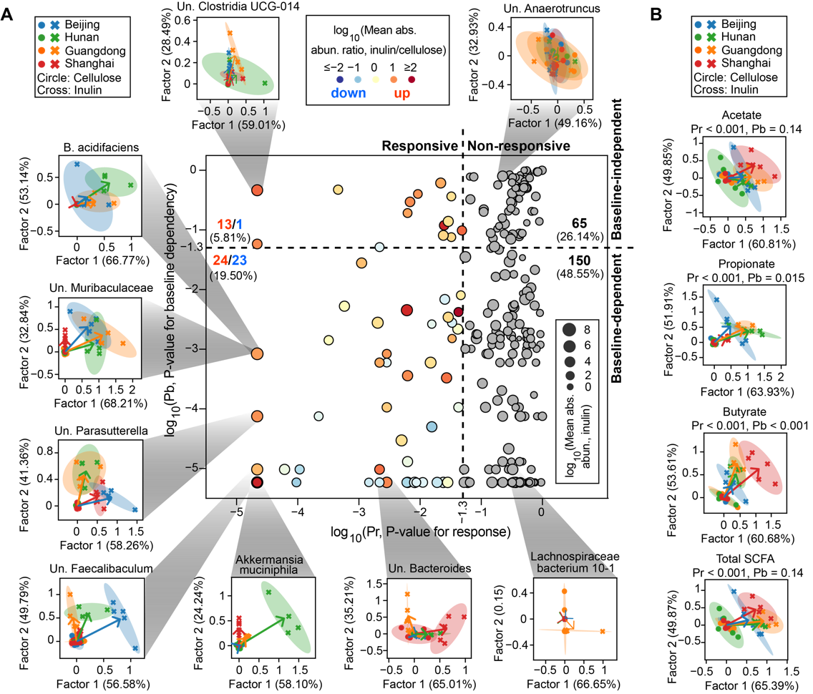

**Figure 4.** **Visualization and quantitative significance test of baseline-dependent responses of bacterial species (A) and short-chain fatty acids (SCFAs) (B) to inulin intervention.** The scatter plot in panel A distinguishes four different scenarios of baseline-dependent responses depending on the P-values for significance test of responsiveness (Pr) and baseline-dependency (Pb). The non-responsive bacterial species are marked as gray dots, while the responsive ones are colored by the ratio of their averaged absolute abundances (abs. abun.) between inulin and cellulose group. We displayed the inulin-stimulated longitudinal responses of bacterial species and SCFAs, relative to their corresponding responses in the cellulose group, in a reduced two-dimensional (2D) space spanned by factor 1 and factor 2 extracted using sequential non-negative matrix factorization (see Methods for details). In the 2D visualizations, each symbol represents a mouse (dots: cellulose group, crosses: inulin group) and all mice data from the same vendor under the same dietary fiber treatment was used to fit an eclipse. For each vendor, an arrow was drawn from the eclipse center of the vendor under cellulose treatment (standardized to the origin) to that under the inulin treatment. Numbers in parentheses on x- and y-axis labels indicate factor loadings. Taxonomic labels w/ “Un.” group bacteria that are unclassified or uncultured at lower taxonomic ranks.

**Baseline- and time-dependency impedes prediction of SCFAs from microbiota composition.** Prediciting metabolomes from microbiota compositions and inferring the bacterial taxa that produce and consume metabolites are of long-standing interest for microbiome scienece. However, there has been much controvercy regarding whether metabolome, especially SCFAs, is predictable from gut microbiome. Here we evaluated the performance of machine learning models to predict the SCFA concentrations measured in our study. We implemented two train-test data split strategies: “intropolation” and “extrapolation”. “Intrapolation” balanced vendor distribution between training and testing datasets by collecting a single mouse from each vendor into testing and the rest of mice into training. By contrast, “extrapolation” used all mice from three vendors as training and the last one as testing data. Therefore, the training-test similaring is much smaller in “intrapolation’ split than “extrepoaltion”. Not surprisingly, the prediction power is 10-45% for intrapolsaiotn and generally less than 0 for extrapolation. For “intrapolation”, butyrate is most predictablea and acetate is the least, which may be due to butyrate is only produced by a few family while acetate can be widely produced from phylum. Even after hyperparameter tuning and cross-validation, there remains singificnat overfitting as the training accuracy is at least 65% regardless of SCFAs and data-split stratiegy. We further showed that the poor performance of predicting extrapolation dataset cannot be rescued by altering predictors and using different models (Fig. SX). The prediction of SCFA from microbniota following resistant starcb intervention is even worse with much lower R2 (Fig. SX).

We hypothesized that the poor performance of random forest model stemmed from baseline-dependency of SCFA concentrations. By plotting the presence and absence of each species in the baseline samples from different vendors (Fig. 5C and SX), we found that >50% bacterial species was only present in a subset of mice and >70% was not present in all vendors following inulin intervention. For resistant starch intervention, the percentage is similar with >50% and >70% bacterial species missing in at least one mouse and at least on vendor respectively. More formally, we used random forest classifier to test the similarity of gut microbiota between training and testing dataset. Regardless of the dietary fiber intervention, we found that testing set can be almost completely predictable from the training set in the “extrapolation” strategy while the two sets are mostly indistinguiable in the “intrapolation” strategy (Fig. 5D and SX). The phenomenn of train and testing distribution is called “covariant shift”, which can sometime be remedified by adding more weights to samples in the training set that are closer to the testing datasets. However, the gut microbiota in the training and testing sets seem to be too different such that adding sample weights does not improve the prediction accuracy (Fig. SX).

Other than baseline composition, the dynamic feature of gut microbiota and SCFAs also present challeneges in modeling their relationships. By regressing SCFAs concentration on absolute abundance of microbes, we implicitly assume that SCFAs concentration remains unchanged if gut microbiota has a steady composition. However, this does not hold true at the initial responses when SCFAs concentration greatly increases at relatively stable gut microbiota composition. As suggested by Xiao et al., the gut microbiota is far from carrying capacity and resembles an in vitro community where the microbiome-metabolome relationship follows a rate model, i.e., gut microbiota composition determines the change, instead of the absolute concentration of, SCFAs concentration. Using propionate as an example, we trained a random forest model using only the baseline and 1 day data, identifying that unclassified Parabacteroides is the most likely propionate producer. Clearly, the quantitative relationship between propioinate change and absolute abundance of unclassified Parabacteroides disappear in data after 1 day. The finding that unclassified Parabactoierder as the top producer is promising, not only due to in vitro support of its fermentation capability, but also it explains why Shanghai mice has a low propionate level. Note that the low propionate cannot be convincely explained by low biomass as its acetate and butyrate levels are at comparable levels to the other vendors. Using genome-scal emodels, we further show that coculture of Bacteroides and Parabacterois can benfit growth of each other as well as propoionat production.



**Figure 5.** **Robust learning of microbiome-metabolome relationship** **is** **challenging due to baseline-dependency. A**. Two data-splitting strategies for testing model performance using machine learning models. Mice in the testing sets were randomly selected on a one-per-vendor basis for “interpolation” and exclusively selected from a single vendor for “extrapolation”. **B**.Training and testing accuracy in Random Forest regression models trained on absolute abundance of bacterial species. Data in day 0 were removed from the analysis. **C**. Presence (threshold: 0.001%) and prevalence of bacterial species in baseline microbiota across mice and vendors. Species absent in any mouse baseline sample were not shown. In the bottom panel, the prevalence score of a species across mice (solid line) was defined as the fraction of mice that contains this species in their baseline microbiota and that across vendors (dashed line) was the fraction of vendors whose mice all contain this species. **D**. Receiver operating characteristic (ROC) curve analysis of the similarity between training and testing datasets. A Random Forest classifier trained to discriminate the two datasets outputs area under the ROC curve (auc) as a similarity score (see Methods for details).

**Discussion**

# Summary of the major findings of this study

In this study, we investigated two sources of individualized dietary responses: basline composition and dyanmcis of gut microbiota. By charactering the dynamical responses of gut microbiota and SCFAs following interventions of inulin and resistant starch for 31 days, we found that (1) resistant starch showed mild effect on gut microbiota composition and SCFA metabolism; (2) the dynamical responses generally follow biphsic patterns but there are baseline-dependency. Both dynamical patterns and baseline-dependence are interpretable and tied to the responder: the biphasic responses are attributed to the ecology (growth and competition) of a few responders and the baseline-dependency is attributed to the lack of some responders. Compared to baseline dependency, the ecological effects seem to be stronger and can overcome the intial condition difference as the gut microbiota become more similar after 31-day intervention. However, the importance of baseline dependency is plays important roles in predicting SCFAs from gut microbiota.

# Discuss the relevance of our studies to the literature

Some previous cross-sectional studies found that dietary fiber, including inulin, alters gut microbiota compositions without significant changes in fecal metabolite profiles. The lack of responses in SCFAs metabolism may be linked to the timing when the dietary responses assessed. Our longitudinal data suggests that SCFAs concentration decreases after an transient peak. By comparing the SCFA concentrations between day 0 and day 31, our data also shows no evidence of significant changes of SCFA concentrations. It has been observed that these diet-induced microbial and metabolic changes are transient and disappear shortly after cessation of a dietary initiative [25-28] and gut microbiota enterotypes are associated with long-term diet, and does not alter by short-term feedings. Our experiments add to this finding by showing that even under prolonged dietary intervention and continuous dietary fiber intake until 4 weeks [29], SCFAs concentration cannot be maintained and decreases after a quick increase. This is in line with previous research in humans, showing that the production and concentration of SCFAs in response to treatment with fiber in patients with colonic cancer dropped down after the initial elevation before sixth week [30]. Despite, our data clearly shows that a 31-day intervention is sufficient to permanently alter the compositional state of the microbiota community, despite it remains unknown whether the new ecological state persists after the intervention discontinues. We envision two possibilities of the decreased SCFA concentration in phase II. First, some bacteria can degrade SCFAs in time-dependnt manner. For example, Clostridium acetobutylium can first produce acetate and butyrate in the vegetative growth phase (phase I), which can later be reassimilated to produce acetone, butanol, and ethanol in the solventogenic phase (phase II). The acetate and butyrate concentrations shows similar increase-and-then-decrease pattern. Second, absorption of SCFA in the GI tract, however, plays an important role in resulting fecal SCFA concentrations [[24](https://www.futuremedicine.com/doi/full/10.2217/bmm-2020-0353?casa_token=DY6co5Fp_ysAAAAA%3Anqq7r0PXl7S0C0RJakByEpOr4eisdtijooc0r7cRImxk-4EZ84raOGJdPVxcgftxqJLY1d9vYaqW" \l "B24)]. In healthy individuals, about 5% of produced SCFA are excreted with the fecal matter [[25](https://www.futuremedicine.com/doi/full/10.2217/bmm-2020-0353?casa_token=DY6co5Fp_ysAAAAA%3Anqq7r0PXl7S0C0RJakByEpOr4eisdtijooc0r7cRImxk-4EZ84raOGJdPVxcgftxqJLY1d9vYaqW" \l "B25)]. Fecal butyrate levels were found to be increased in patients with diarrhea-predominant irritable bowel syndrome compared with healthy controls, but reduced in patients with constipation-predominant irritable bowel syndrome [[26](https://www.futuremedicine.com/doi/full/10.2217/bmm-2020-0353?casa_token=DY6co5Fp_ysAAAAA%3Anqq7r0PXl7S0C0RJakByEpOr4eisdtijooc0r7cRImxk-4EZ84raOGJdPVxcgftxqJLY1d9vYaqW" \l "B26)].

# Does SCFAs response require miocrbiota changes?

In our study, miocrbiota changes always lead to changes in SCFAs. However, the reverse statement is not true as Shanghai mice has a delayed moicrbiota changes but the acetate and butyrate productions are quick and immediate following interventions. This suggests that the responses of gut microbiota and SCFAs were not tightly linked. It is likely that the SCFAs concentration may be promoted through gene expressions rather than population density of the SCFA producers, which may explain the difficulty of identifying SCFA producers from the data. In fact, there is little overlap of the identified SCFA produces between random forest model and repeated correlation (Fig. SX). [Evidences]

More interestingly, This suggests that the measurement of gene-level changes may be as important as the measurement of community composition, justifying the essentiality of integrating transcriptomics and other omics data in the dietary response analysis.

# General advantages of our inference approach and how it helps curb the replicability issue

By combining gLV model and Bayesian regression, we identified multiple inulin responders from the complex microbial community of the murine intestine, which we believe play critical roles in the complex process of fiber degradation and metabolism. Compared to statistical inferences involving hypothesis testing, our gLV-based inference approach has two main advantages. First, gLV is a differential-equation model and thus naturally more ameanable to analyzing longitudinal data. By contrast, statistical tests are typically cross-sectional and make comparisons at single time points. For example, we found that bacteria whose relative abundances were significantly altered by inulin vary depending on the day of sample collection (Fig. SX). More importantly, the structure of gLV allows for modeling bacterial interactions as covariants and accounting for confounding variables reduces the risk of producing biased estimates of indirect effects. Any scientific field, including microbiome science, that heavily relies on complex statistical anlaysis of large datasets may encounter chanllenges in replicability—previous results cannot be replicated by new investigators. Among all factors that may hinder replication, failure to accounding for confounding variables presents a major threat that may lead to inconsistent findings. Remarkably, our inference approach applied to different mouse or human gut microbiome data produced highly consistent results regarding inulin responders. In the mouse gut, both our own data and data from Chichiwa et al agree that Bacteroides acidifaciens was the strongest inulin responder. Reanalysis of five human studies that all administered inulin revealed that Bifidobacterium (in 4 out of 5 studies) and Anaerostipes (in 5 out of 5 studies) exihibit significant responses to inulin, despite the huge differences in the pretreatment microbiota composition among human subjects in these studies (Fig. SX). Both genera have been found to be impacted by inulin-type fructans supplementation in previous studies.

# Discuss the failure of predicting SCFAs from microbiota

There has been much controversies concerning the feasibility of predicting metabolite profiles solely based on microbiomie sequencing data. For example, the MelonnPan algorithm based on penalized linear regression successfully predicted relative abundances of >50% metabolites from metagenomes in patients with inflammatory bowel disease and healthy controls. On the other hand, it was also reported that only 14% of the observed variation in the SCFAs concentration can be explained by Random Forest regression models trained on 16S rRNA or metagenomic gene sequences in colorectal cancer patients and healthy controls. While the possibility of using different regression models and patient cohorts between these controveral studies cannot be exlucded, our study points out that the similarity of data distribution between training and test sets, which is tighly linked to the degree of inter-individual variability of gut microbiota in the cohort data, strongly contributes to the disagreement. In Fig. 5, we showed that the predictability was completely lost when extrapolating models to predict SCFAs from gut microbiota types that were unseen during training. Considering that stratified train-test split may or may not be implemented, the training and test datasets may or may not be independent and identicially distributed (i.i.d.), yielding inconsistent model performances. Even though data is split based on microbiome characteristics in a straitified fashion, regression models may still perform poorly in cases when the inter-individual variabilty is too large to fulfill the i.i.d. assumption, the break of which would cause covariate shift and maching learning to fail.

# Limitations in translating knowledge from mice experiments to human

We note two major limitations that may hinder translating the insights provided from our mouse experiments to humans. First, mice have much less inter-individual variability than humans. Since individual mice in our study can be stratified into four distinct microbiome types based on vendors, the major conclusions we draw were essentially based comparative analysis of dietary responses among the four microbial communities each with several replicates. Whether and how well the four communtiy types correspond to the enterotypes—distinct micrbiome configurations—in humans are worth further study. To soften this limitation, we have made efforts to augment the microbiome diversity by reanalyzing public datasets from similar studies. Second, the murine gut microbiota has distinct compositions from humans [39]. Although Bacteroidetes and firmicutes are the two major phyla in both mice and human, 85% genera found in the mouse gut are not detectable in the human gut. For example, the family Muribaculaceae—a major inulin responder inferred by this study—was specific to the mouse gut. Moreover, the differences in microbiome structure between mice and human diversify the gut environment between the two ecosystems, both metabolically and ecologically, causing dietary responses to be context-dependent. For instance, the two human inulin responders—Bifidobacterium and Anaerostipes—were present in the mice gut but their relative abundances remain low and unresponsive to inulin intervention throughout the entire period of observation (Fig. SX). The example shows that bacteria responding to dietary fiber in one of the two mammalian systems may not consistently respond in the other, suggesting that community ecology may play an selective role in the activation of fiber degraders depending on the surrounding environment. Despite these drawbacks, many confounding variables that are difficult to account for in human studies (e.g., age, sex) have been well controlled in our mouse experientments, leaving microbiome as the only major factor that differs between individual mice showing heterogeneous dietary responses.

**Conclusions**

**Methods**

**Animal experiment.** Specific-pathogen-free (SPF) female C57BL/6J mice for different gut microbial composition were obtained at 6 weeks of age from Beijing (A Charles River Company, Beijing, China), Hunan (Hunan Slac Jingda Laboratory Animal Company, Ltd., Changsha, China), Guangdong (Guangdong Medical Laboratory Animal Center, Foshan, China)), Shanghai (SLAC Laboratory Animal Co., Ltd., Shanghai, China). Mice were maintained on a 12-h light/dark cycle and allowed ad libitum access to food and water throughout the experiment. After acclimatizing to the diet and housing environment for 1 week, mice from each vendor were randomly separated into three groups: cellulose group, resistant starch group, and inulin group (n = 5). Composition of all diets including the source of dietary fibers cellulose, resistant starch, and inulin are provided in supplementary table 1 (**Table S1**). Fecal pellets from each mouse were freshly collected over multiple time points: day 0 (before diet change), day 1, 3, 5, 8, 13, 19, 25, and 31 (Figure 1A). Fecal samples were snap-frozen in liquid nitrogen and stored at −80 °C until further processing. At every cage change (moving the mice to a new clean cage with fresh bedding twice in one week), body weight was individually measured, and food intake and fecal output of each cage mice during the past three days per cage were measured. This study was performed in accordance with the recommendations of the National Care and Use of Animals Guidelines (China) and approved by the Institutional Animal Care and Use Committee (IACUC) of the Shenzhen Institutes of Advanced Technology, Chinese Academy of Sciences.

**GC-MS analysis of fecal SCFA concentration.** The SCFAs were analyzed according to the previous studies with modifications [42]. For the sample extraction, 0.05 g of frozen feces were mixed with 300 µL of pure water containing caproic acid-6,6,6-d3 (CDN Isotopes, Quebec, Canada) as internal standard (IS, final concentration 20 µg/mL). After adding 1.0 mm diameter zirconia/silica beads (BioSpec, Bartlesville, OK), feces were homogenized for 20 s under 6500 rpm for three times, then incubated at 4 °C with shaking for 30 min, followed by centrifugation for 30 min at 13,000×g. Following extraction with anhydrous diethyl ether, the SCFA extract accurately transferred into a glass insert in a GC vial and capped tightly after added 5 µl of N, O-bis(trimethyl-silyl)-trifluoroacetamide and vortexed for 5 s. The mixture was kept in the GC vial and incubated at room temperature (22 °C) overnight (or over 8 h) before loading to GC/MS. The analysis of acetic, propionic and butyric acids was performed by Agilent 8890/7000D triple quadrupole GC/MS equipped with a capillary HP-5 ms capillary column (30 m × 0.25 mm × 0.25 µm film thickness) (Agilent Technologies). The analytes were quantified in the selected ion monitoring (SIM) mode using the target ion and confirmed by confirmative ions. The concentration was determined with reference to the peak side of IS.

**DNA extraction and quantification of bacterial load.** For extraction of DNA, fecal material from pellets was extracted using the QIAmp PowerFecal DNA kit (Qiagen, #12830–50) following standard manufacturer procedures. DNA samples were resuspended in Buffer C6 and quantitated using the Qubit fluorometer (ThermoFisher Scientific). To quantitatively assess bacterial load, total bacteria cell counts were determined using qPCR as described recently [43].

**Amplicon and metagenomic sequencing.** 16S rRNA gene sequencing was performed as previously described with modifications [44]. Library preparation was done using a two-step PCR method. During the first step of PCR, primers S-D-Bact-0341-b-S-17 and S-D-Bact-0785-a-A-21 were used to target and amplify the v3-4 region, as well as to add second-step priming sites. Dual index codes were added to each sample at the second PCR step. The PCR products were purified with Agencourt AMPure XP magnetic beads (Beckman Coulter, Brea, CA, USA) and quality controlled with TapeStation (Agilent Technologies, Santa Clara, CA, USA). The final DNA concentrations of the purified products were measured with a Qubit 2.0 fluorometer (Thermo Fisher Scientific). The purified products were pooled in equal molar concentrations, and denatured following the Illumina protocol. All sequencing was done in a single run, which was performed with a 250-cycle SP kit on the NovaSeq 6000 following the NovaSeq XP workflow (Illumina, USA). Blank controls (no sample added, processed routinely, n = 4) were included in the extraction process to control for contamination throughout processing.

Metagenomic sequencing was performed using fecal samples from the inulin diet group at day 0, 5 and 31. Extracted DNA sample was purified using silica-based columns. Metagenomics sequencing libraries were prepared with at least 2 μg of total DNA using the Nextera XT DNA sample Prep Kit (Illumina, San Diego, USA) with an equimolar pool of libraries achieved independently based on Qubit 2.0 fluorometer results combined with SYBR Green quantification (Thermo Fisher Scientific, Massachusetts, USA). The indexed libraries were sequenced with a 150-cycle S4 kit on the NovaSeq 6000 following the NovaSeq XP workflow (Illumina, USA).

**Sequence analysis**. The 16S rRNA sequencing reads were analyzed in QIIME 2-2020.2 software [45]. Demultiplexed paired-end reads were trimmed to remove primers and low-quality bases with q2-cutadapt plugin. The trimmed sequences were denoised and joined with q2-dada2 plugin. Potential reagent contaminants were identified using decontam package based on either the frequency of the ASV in the blank control or the negative correlation with DNA concentration [46]. The generated feature table was filtered to remove ASVs present in only a single sample and remaining ASVs were used to construct a rooted phylogenetic tree via q2-phylogeny. Rarefaction curve analysis of the data obtained was used to estimate the completeness of microbial communities sampling and performed using the iNEXT R package [47]. Subsequently, in order to avoid sample-to-sample bias due to variable sequencing depth (different number of reads per sample), samples were rarefied to 38,980 sequences per sample. Rarefaction analysis showed that great majority of the bacteria species diversity and richness that could be sampled was captured by our sequencing depth (**Supplementary Fig. 18**), indicated sufficient sequencing depth for majority of the analyzed samples. Estimated alpha diversity metrics, beta diversity metrics (Aitchison distance [20]) and Principle Coordinate Analysis (PCoA) using q2-diversity. Group significance between alpha and beta diversity indexes was calculated with QIIME2 plugins using the Kruskal–Wallis test and permutational multivariate analysis of variance (PERMANOVA), respectively. To assign taxonomy to the amplicon sequence variants (ASVs), the q2-feature-classifier basing on the classify-sklearn naïve Bayes taxonomy classifier was used with the SILVA (v.138) as reference database.

For metagenome analysis, raw sequencing reads were subjected to quality filtering and barcode trimming using KneadData (v0.5.4) by employing trimmomatic settings of 4-base wide sliding window, with average quality per base >20 and minimum length 90 bp. Reads mapping to the mouse genome were also removed. Kraken2 was run against genome taxonomy database (GTDB_r89_54k) with default parameters [47]. Following classification by Kraken2, Bracken was used to re-estimate bacterial abundances at taxonomic levels from species to phylum using a read length parameter of 150. Next, the filtered sequences were assembled into contigs using metaSPAdes with default settings [49]. The gene abundance was analyzed and calculated as previously described with modifications [50]. Putative genes were then predicted on contigs longer than 200 base pairs using Prodigal under metagenome mode (-p meta) [51]. A non-redundant gene catalogue was constructed with CD-HIT using the parameters “-c 0.95 –aS 0.9” [52]. The abundance of each predicted gene was evaluated by mapping reads back with KMA algorithm and then normalized with the following equation: RPM = 1M × (mapped reads/gene length)/(sum of mapped reads/gene length) [53]. For all the predicted genes, CAZymes were annotated using hmmsearch against the dbCAN2 database V9 (e value <1 × 10−10; coverage >0.3) [54]. The domain with the highest coverage was selected for sequences overlapping multiple CAZyme domains. For all samples, short genomic assemblies (<2,000 bp) that could have biased the subsequent analysis were first excluded. Genomes were then binned using VAMB [55]. The binning results were refined based on the bin quality assessment (completeness >75, and contamination <15) of different binners from CheckM [56]. Taxonomic classification of each bin was determined by GTDB-tk [57], and subjected to prediction of polysaccharide utilization loci (PULz) using pipeline PULpy [58].

**Statistical analysis.** R packages *qiime2R*, *ANCOM*, *phyloseq*, *DESeq2*, *RandomForests*, *vegan*, *cluster*, *ggpubr*, *ggtern*, *rstatix*, and *ggplot2* were used for normalization, analyses, and visualization. For normally distributed continuous variables, the mean values were examined using an unpaired Student’s t test or One-way ANOVA with Tukey’s post hoc test. The level of significance was set at *P* < 0.05. Differential CAZY genes and bacterial CAGs between time points were identified using Wilcoxon matched-pair signed-rank tests (two-tailed) followed by FDR corrections.

Beta diversity: Beta diversity, which illustrates differences in taxonomic diversity between different vendors were examined using recently developed tools that are robust for investigating compositional data: DEICODE [20].

**Supplementary figures:**

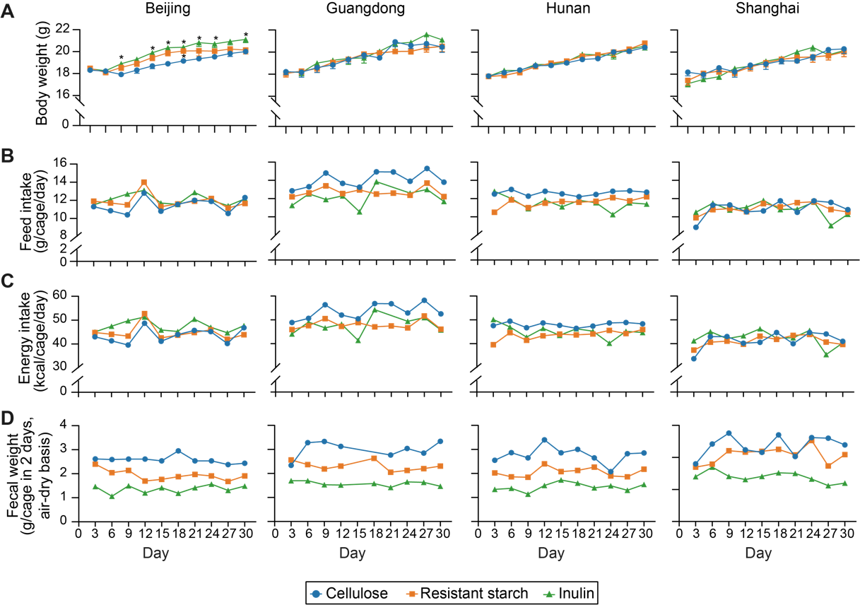

**Figure S1. (Related to Fig. 2) Effects of inulin or resistant starch on (A) body weight, (B) daily food intake, (C) daily energy intake, and (D) 48-hr fecal sample weight of mice receiving diet supplementation used in this study.** Each symbol represents the mean body weight in panel A or a single data point in panels B-D. The body weight data were analyzed by ordinary one-way ANOVA with Turkey post hoc test between inulin or resistant starch and cellulose group. *, P < 0.05.

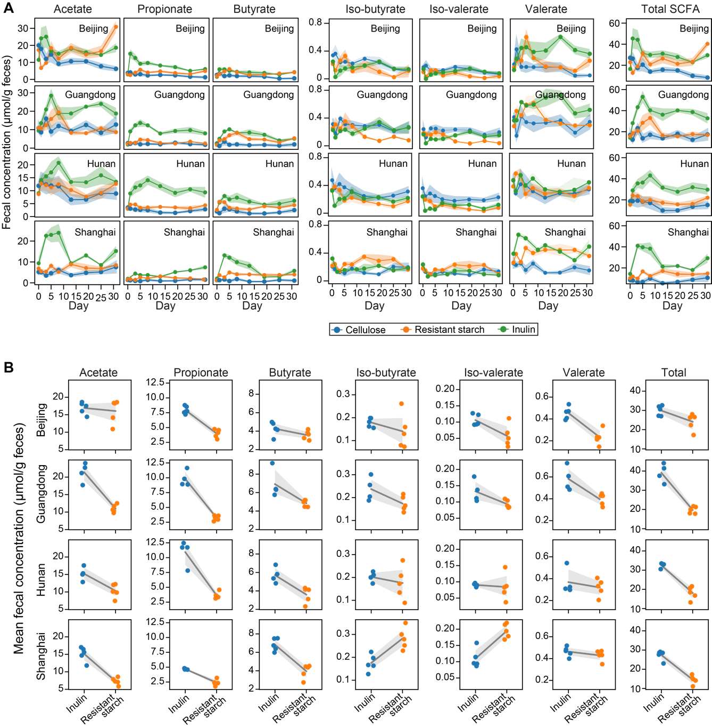

**Figure S2. (Related to Fig. 2) Dynamics (A) and time averages (B) of fecal short-chain fatty acid (SCFA) concentration following dietary fiber intervention.** Lines represent mean concentrations across mice and shading areas represent standard error of the mean.

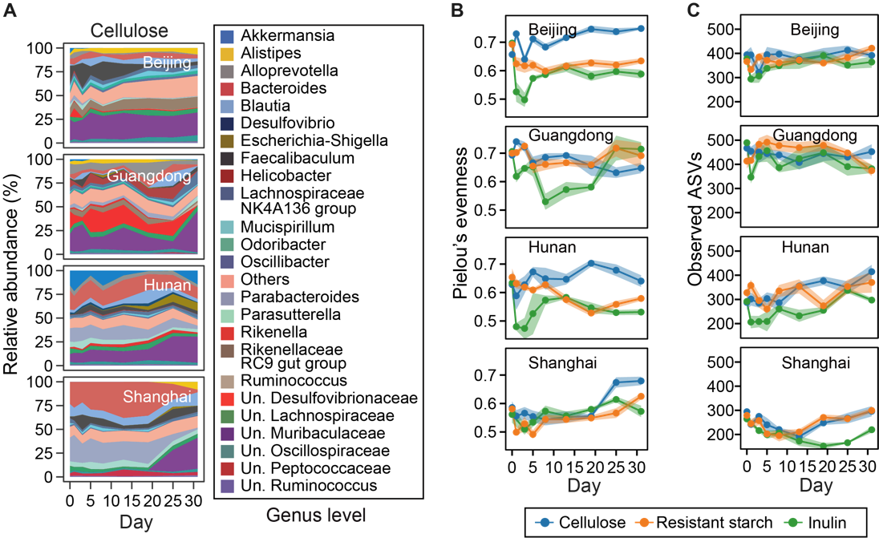

**Figure S3. (Related to Fig. 2) Dynamics of cellulose-group microbiota composition (A), evenness (B), and number of observed ASVs (C) following dietary fiber intervention.** For panel A, taxonomic labels w/ “Un.” group bacteria that are unclassified or uncultured at lower taxonomic ranks. For all panels, the heights of stacked bands (panel A) or lines (panels B, C) represent mean values across mice within the same vendor and shading areas (panels B, C) represent standard error of the mean.

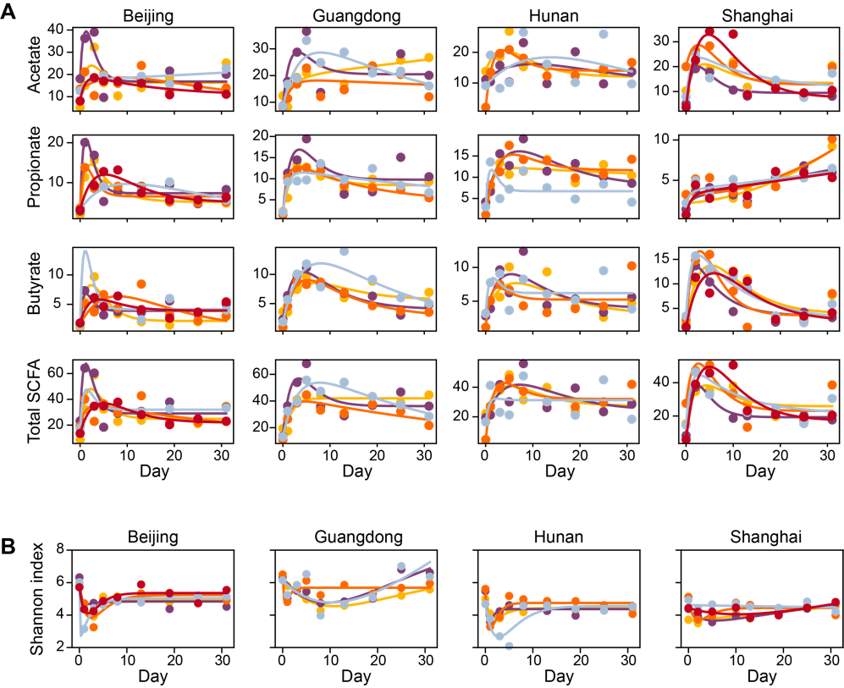

**Figure S4. (Related to Fig. 2) Fitting a harmonic oscillator model to the dynamics of short-chain fatty acids (A) and Shannon diversity (B).** Dots represent data and lines represent simulations using the best-fit parameter values. Both lines and dots are color-coded on a per-mouse basis.

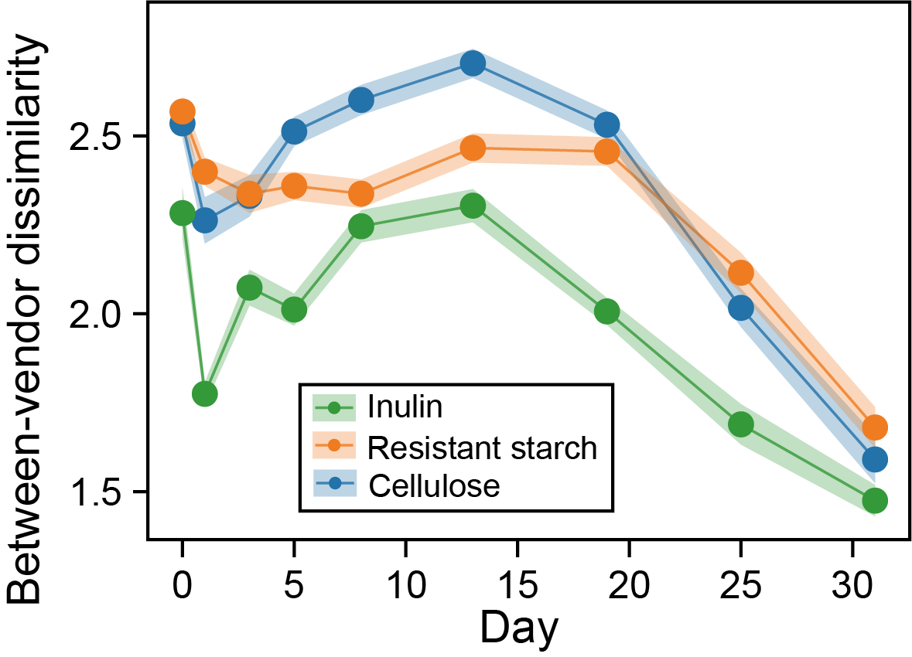

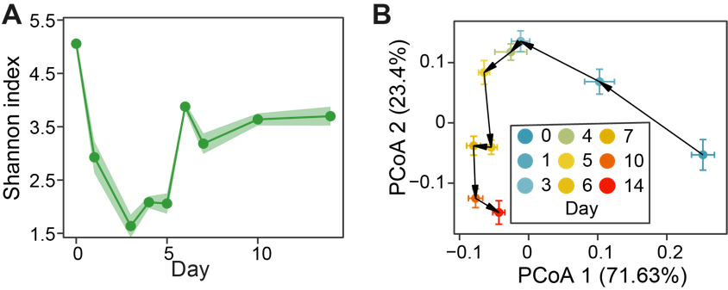

**Figure S5. (Related to Fig. 2) Reanalysis of data from Chijiwa et al., 2020, where** **a similar experiment was performed to observe the gut microbiota dynamics following inulin treatment in a mouse model.** **A**. Alpha diversity. **B**. The averaged response trajectory of gut microbiota in PCoA (principal coordinate analysis) ordination scatter plot. Each dot represents the mean principal coordinate score of all mice and the corresponding error bar represents the standard error of the mean.

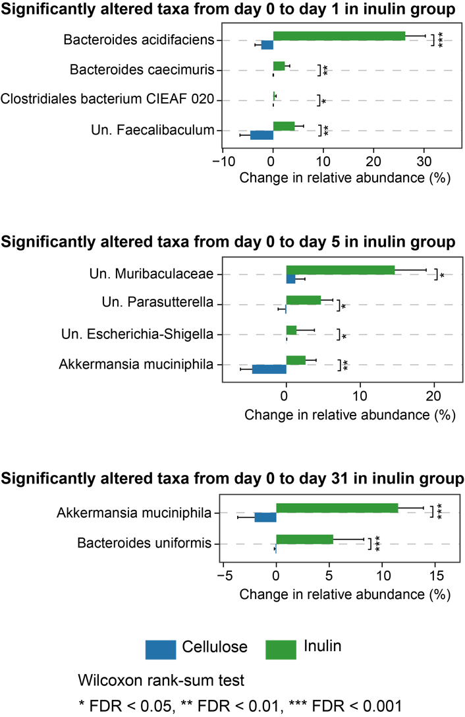

**Figure S6.** **(Related to Fig. 3) Significantly altered bacterial species in relative abundance between inulin and cellulose groups.** The identified species vary depending on the day of observation.

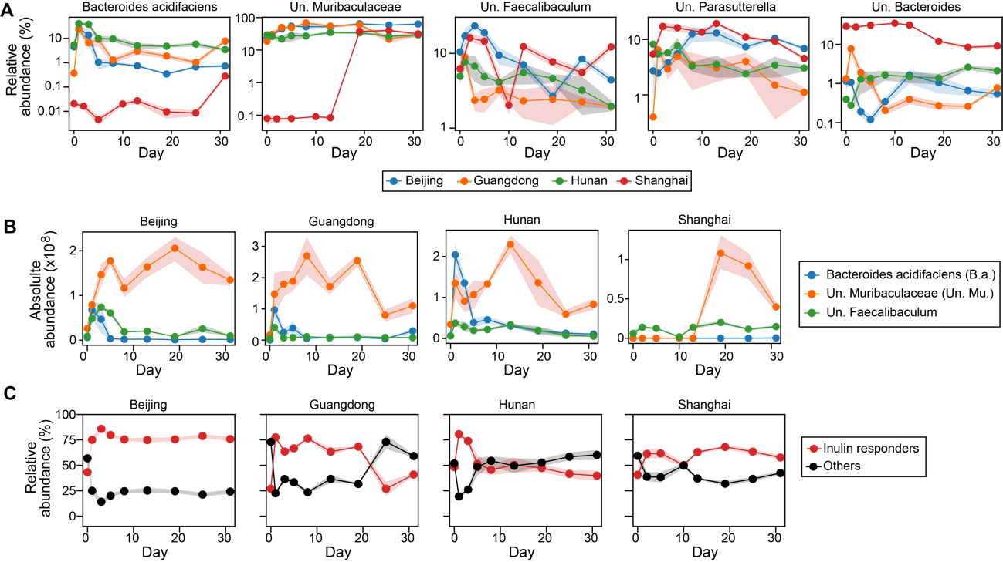

**Figure S7. (Related to Fig. 3) Dynamics of inulin responders.** **A**. Relative abundance of each inulin responder inferred from ecological network model. **B**. Three responders that might compete for inulin (see the main text Fig. 3F for inferred interspecific interactions). **C**. Comparison of total relative abundance between inulin responders and other bacterial species.

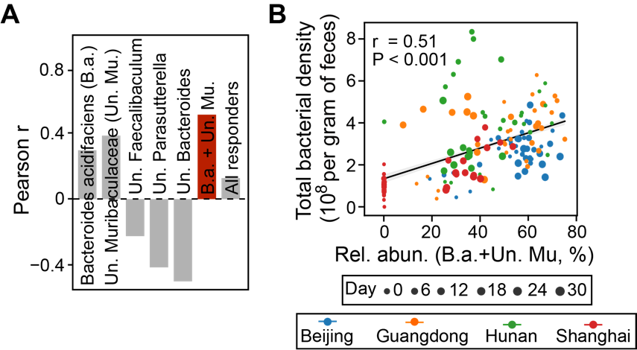

**Figure S8. (Related to Fig. 3) Prediction of total bacterial density (i.e., absolute abundance) from relative abundance of inulin responders.** **A**. Pearson correlation for different combinations of inulin responders. The red bar has the highest correlation coefficient. **B**. Scatter plot showing the positive correlation of the combined relative abundance of Bacteroides acidifaciens (B.a.) and unclassified Muribaculaceae (Un. Mu.) with total bacterial density. Gray line: linear regression (Pearson r and P-value are indicated in the plot); shading area: standard error of the regression.

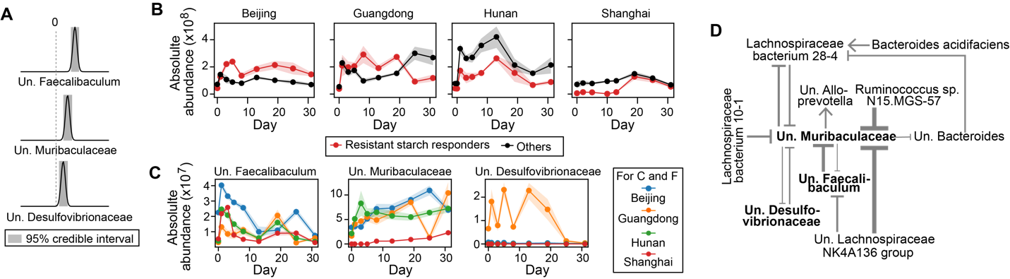

**Figure S9. (Related to Fig. 3) Inferring bacterial responders to resistant starch intervention and associated ecological interaction network.** The same figure legend applies as in the main text Fig. 3C-H (the same order).

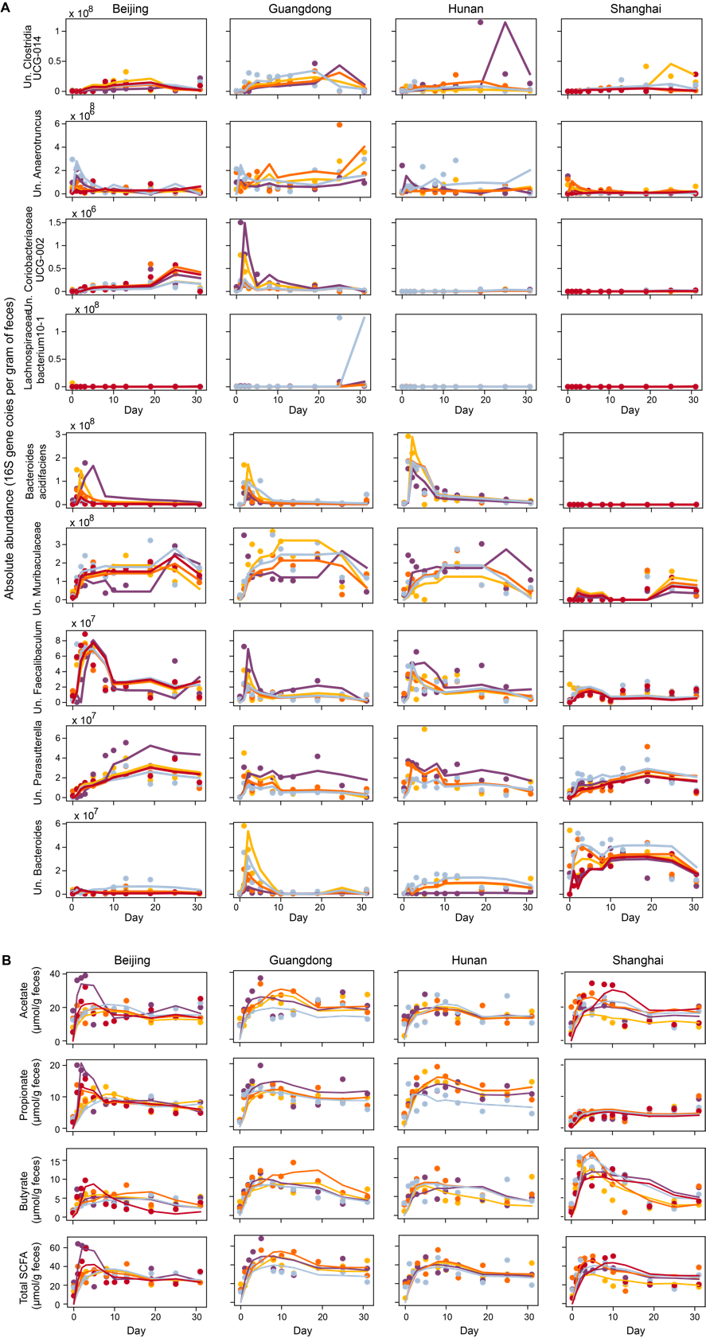

**Figure S11. (Related to Fig. 4) Reconstructed time series (lines) of selected bacterial species (A) and short-chain fatty acids (B) in the main text Fig. 4 using the first two factors of sequential Non-negative matrix factorization.** Dots represent observations and both lines and dots are color-coded on a per-mouse basis.

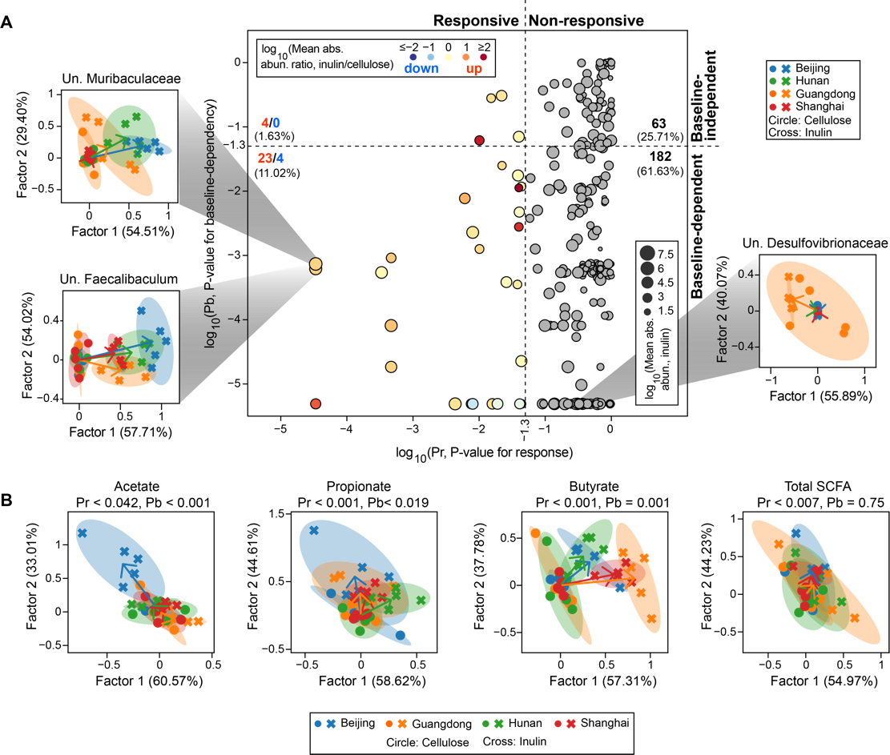

**Figure S12. (Related to Fig. 4) Individualized response analysis of bacterial species (A) and short-chain fatty acids (B) for resistant starch intervention.** The same figure legend applies as in the main text Fig. 4.

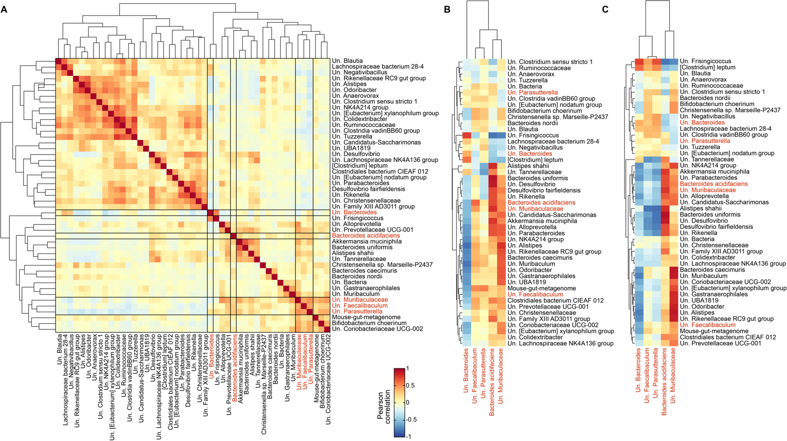

**Figure S13. (Related to Fig. 4) Pearson correlation between species w/ baseline-dependent responses (identified in the main text Fig. 4A) and inulin responders (identified in the main text Fig. 3C, highlighted in red). A**. Correlations were performed using absolute abundances at all time points. **B**,**C**. Correlations were performed using baseline absolute (B) or relative (C) abundances for species w/ baseline-dependent responses and total area under the curve of absolute abundances for inulin responders.

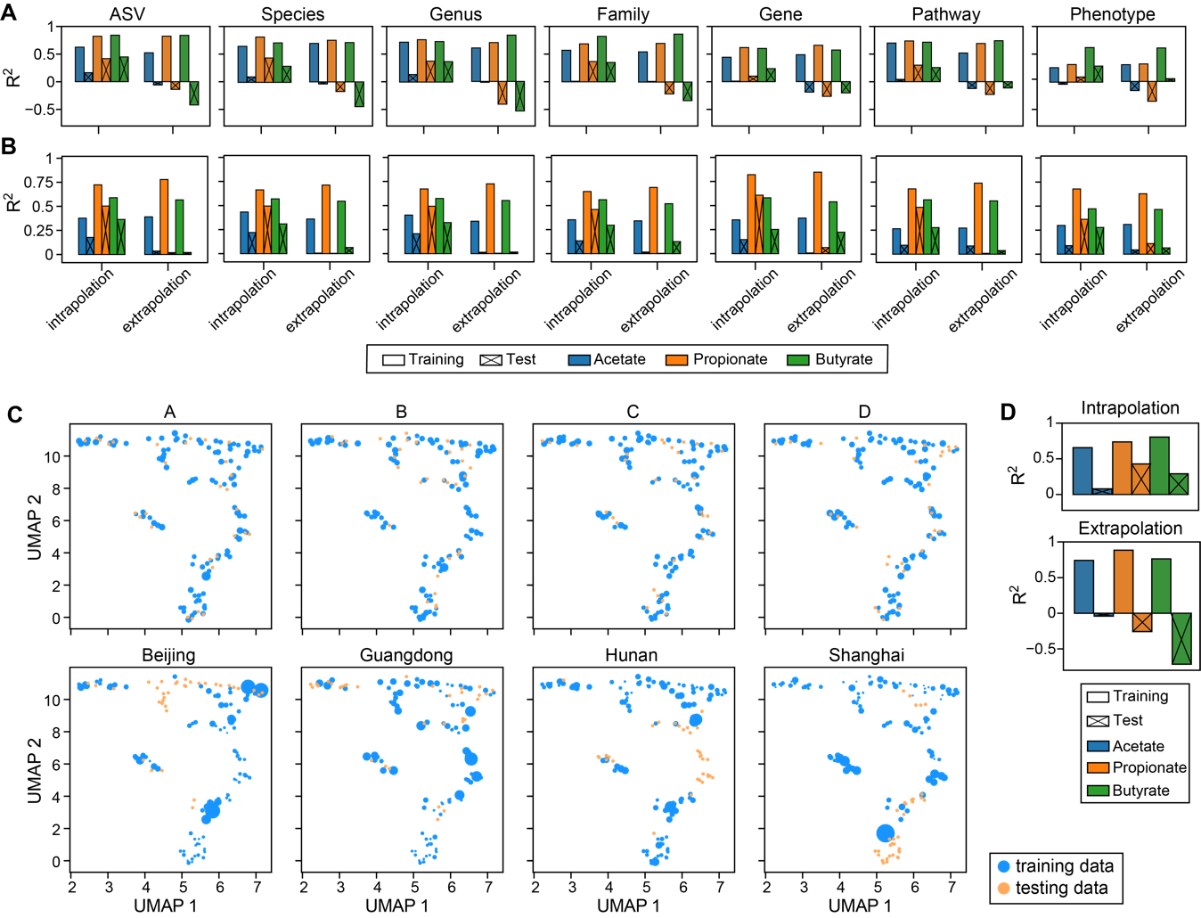

**Figure S14. (Related to Fig. 5) Poor performance of random forest model in predicting short-chain fatty acids (SCFAs) concentration (see Fig. 5B of the main text for results) cannot be rescued by using (A) alternative predictors, (B) alternative regression models, and (C,D) weighting of training samples. A**. Prediction accuracy using random forest regression model and taxonomic (ASV, Species, Genus, Family) or functional (Gene, Pathway, Phenotype) representation of gut microbiota as predictors. The abundances of genes, pathways and phenotypes were predicted using PICRUSt2. **B**. Prediction accuracy using MelonnPan and the same predictors as used in panel A. **C**. Sample weights under different data-splitting strategies. The weights of training samples closer to their corresponding test samples were assigned higher values, as indicated by larger circle sizes in a reduced two-dimensional UMAP (Uniform Manifold Approximation and Projection) space.The sample weight was calculated as 1/Pi-1, where Pi is the probability of sample i belonging to the training distribution and was estimated using random forest classifier (the same approach was applied to generate Receiver Operating Characteristics curves in Fig. 5D of the main text; see Methods in the main text for details). **D**. Prediction accuracy using random forest regression model built from weighted training data and absolute abundances of bacterial species as predictors.

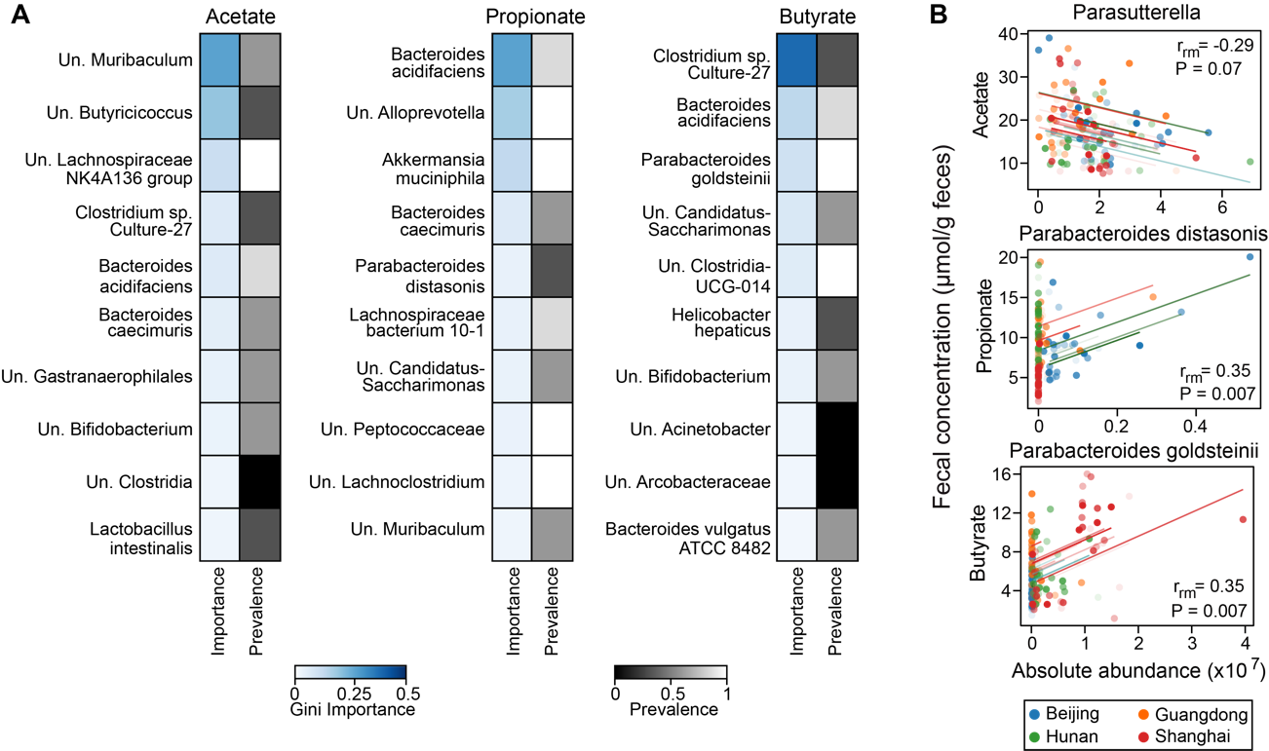

**Figure S15. Inferred short-chain fatty acid (SCFA) producers in inulin-treated mice vary depending on the inference approaches (Random forest regression vs. Repeated correlation analysis). A.** Random forest (RF) regression. For each SCFA, we showed top 10 bacterial species with the highest Gini importance score in model training using all data. The absolute abundances of bacterial species were standardized and filtered (threshold 10-5) by LASSO (least absolute shrinkage and selection operator) regression before passing to RF model. Several key hyperparameters in LASSO and RF were optimized using grid search cross-validation with R2 as the score metric. The vendor-level prevalence scores were obtained from Fig. 5C in the main text. **B**. Repeated correlation analysis. Longitudinal data and correlation trend lines are color-coded on a per-mouse basis. Repeated measures correlation coefficients (*r*rm) and FDR-corrected P-values are indicated in the plot.

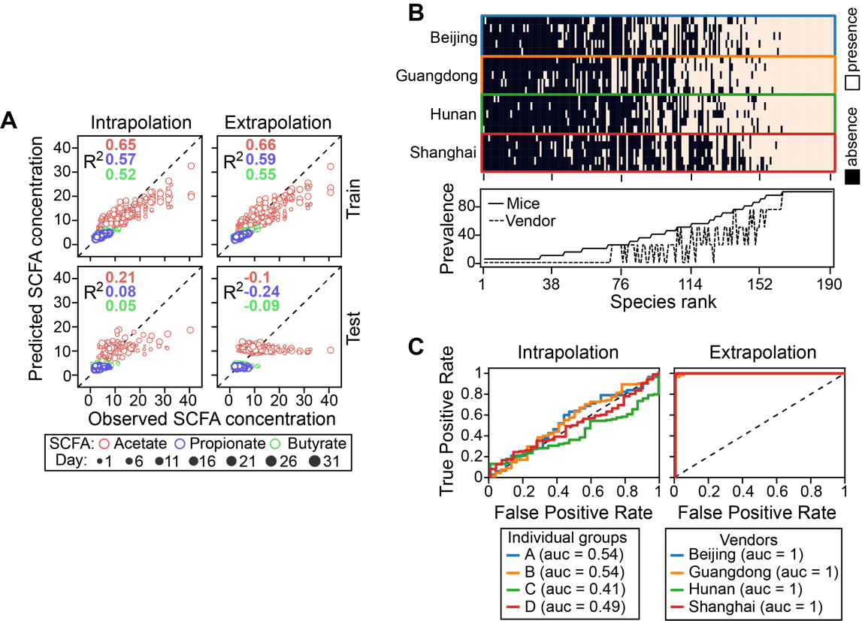

**Figure S16 (Related to Fig. 5) Prediction of short-chain fatty acid (SCFA) concentration from gut microbiota using data from resistant starch-treated mice**. The same figure legend applies as in the main text Fig. 5B-D (the same order).

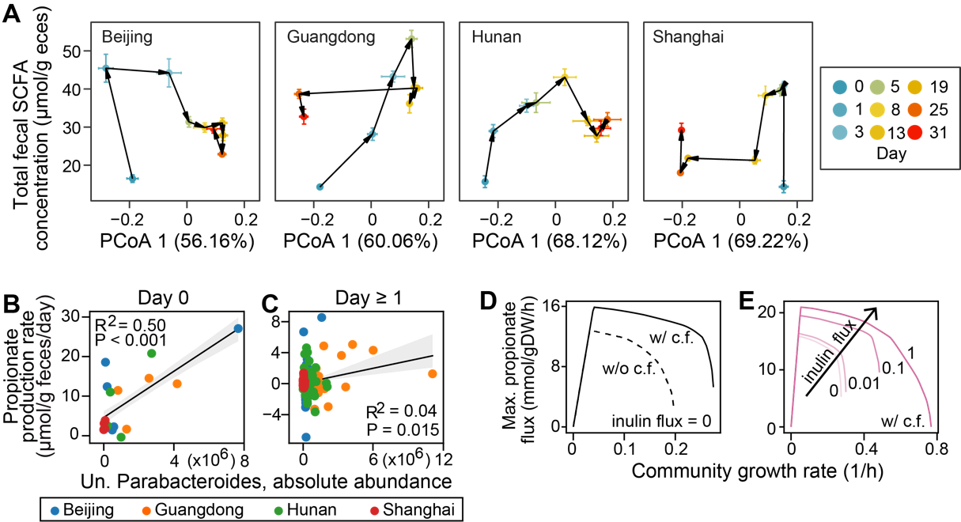

**Figure S17**. **(Related to Discussion)** The quantitative microbiome-metabolome relationship varies in a complex, time-dependent manner. **A**. Dynamics of gut microbiota composition (x-axis) and total SCFA concentration (y-axis) plotted on the same graph. We used the first principal coordinate score from PCoA (principal coordinate analysis) ordination to represent changes in gut microbiota composition (relative abundance) along the direction of maximum variance. Note that SCFA were substantially produced between day 0 and day 1, while gut microbiota composition only changes slightly. Points represent the mean PCoA scores across mice within each vendor and error bars represent the standard error of the mean. **B**-**E**. Potential producers and cross-feeding relationships for initial propionate production within a day of inulin treatment. **B**,**C**. Correlation of baseline unclassified (Un.) Parabacteroides absolute abundance with initial propionate production rates on day 0 (B) and rates in later days (C). Gray line: linear regression (R2 and P-value are indicated in the plot); shading area: standard error of the regression. **D**,**E**. Simulated effects of cross-feeding (c.f.) (D) and inulin availability (E) on growth and propionate flux of two-genera Bacteroides-Parabacteroides community. w/ c.f.: mixing Bacteroides and Parabacteroides in 1:1 ratio; w/o c.f.: mixing Parabacteroides and its clone mate in 1:1 ratio.

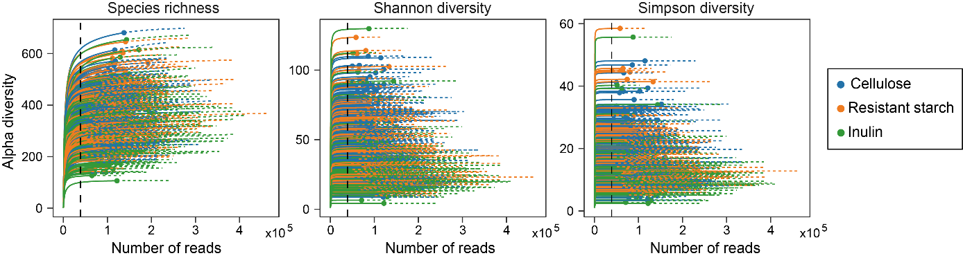

**Figure S18. (Related to Materials and Methods) Rarefaction analysis of 16S rRNA gene clone libraries in terms of species richness, Shannon diversity, and Simpson diversity.** Rarefaction curves were generated using the iNEXT package. Solid lines represent the observed alpha diversity with the number of reads sampled, and dashed lines represent the extrapolation of the solid lines until 25% more reads. To avoid sample-to-sample bias due to variable sequencing depth (different number of reads per sample), all samples were rarefied to 38,980 sequences (black dashed line) per sample before downstream analysis.

**References:**

[1]. Lynch, S.V. and O. Pedersen, The Human Intestinal Microbiome in Health and Disease. New England Journal of Medicine, 2016.

[2]. Sanna, S., et al., Causal relationships among the gut microbiome, short-chain fatty acids and metabolic diseases. Nature Genetics, 2019. 51(4): p. 600-605.

[3]. Nomura, M., et al., Association of Short-Chain Fatty Acids in the Gut Microbiome With Clinical Response to Treatment With Nivolumab or Pembrolizumab in Patients With Solid Cancer Tumors. JAMA Network Open, 2020. 3(4): p. e202895.

[4]. Gentile, C.L. and T.L. Weir, The gut microbiota at the intersection of diet and human health. Science, 2018. 362(6416

): p. 776

-780

.

[5]. Wargo, J.A., Modulating gut microbes. Science, 2020. 369(6509): p. 1302-1303.

[6]. Harkins, C.P., H.H. Kong and J.A. Segre, Manipulating the Human Microbiome to Manage Disease. JAMA, 2019. 323(4): p. 303.

[7]. Gehrig, J.L., et al., Effects of microbiota-directed foods in gnotobiotic animals and undernourished children. Science, 2019. 365(6449): p. eaau4732.

[8]. Zhao, L., et al., Gut bacteria selectively promoted by dietary fibers alleviate type 2 diabetes. Science, 2018. 359(6380): p. 1151-1156.

[9]. Valcheva, R., et al., Inulin-type fructans improve active ulcerative colitis associated with microbiota changes and increased short-chain fatty acids levels. Gut Microbes, 2019. 10(3): p. 334-357.

[10]. Rakoff-Nahoum, S., M.J. Coyne and L.E. Comstock, An Ecological Network of Polysaccharide Utilization among Human Intestinal Symbionts. Current Biology, 2014. 24(1): p. 40-49.

[11]. Solden, L.M., et al., Interspecies cross-feeding orchestrates carbon degradation in the rumen ecosystem. Nature Microbiology, 2018. 3(11): p. 1274-1284.

[12]. Falony, G., et al., Cross-Feeding between Bifidobacterium longum BB536 and Acetate-Converting, Butyrate-Producing Colon Bacteria during Growth on Oligofructose. Applied and Environmental Microbiology, 2006. 72(12): p. 7835-7841.

[13]. Creswell, R., et al., High-resolution temporal profiling of the human gut microbiome reveals consistent and cascading alterations in response to dietary glycans. Genome Medicine, 2020. 12(1).

[14]. Kolodziejczyk, A.A., D. Zheng and E. Elinav, Diet-microbiota interactions and personalized nutrition. Nat Rev Microbiol, 2019. 17(12): p. 742-753.

[15]. Cockburn, D.W. and N.M. Koropatkin, Polysaccharide Degradation by the Intestinal Microbiota and Its Influence on Human Health and Disease. J Mol Biol, 2016. 428(16): p. 3230-3252.

[16]. Ze, X., et al., Ruminococcus bromii is a keystone species for the degradation of resistant starch in the human colon. ISME J, 2012. 6(8): p. 1535-43.

[17]. Salonen, A., et al., Impact of diet and individual variation on intestinal microbiota composition and fermentation products in obese men. ISME J, 2014. 8(11): p. 2218-30.

[18]. Ahmed, W. and S. Rashid, Functional and therapeutic potential of inulin: A comprehensive review. Crit Rev Food Sci Nutr, 2019. 59(1): p. 1-13.

[19]. Cerqueira, F.M., et al., Starch Digestion by Gut Bacteria: Crowdsourcing for Carbs. Trends in Microbiology, 2019.

[20]. Martino, C., et al., A Novel Sparse Compositional Technique Reveals Microbial Perturbations. mSystems, 2019. 4(1).

[21]. Belzer, C., et al., Microbial Metabolic Networks at the Mucus Layer Lead to Diet-Independent Butyrate and Vitamin B12 Production by Intestinal Symbionts. mBio, 2017. 8(5).

[22]. Chijiiwa, R., et al., Single-cell genomics of uncultured bacteria reveals dietary fiber responders in the mouse gut microbiota. Microbiome, 2020. 8(1): p. 5-14

.

[23]. Rakoff-Nahoum, S., K.R. Foster and L.E. Comstock, The evolution of cooperation within the gut microbiota. Nature, 2016. 533(7602): p. 255-259.

[24]. Koropatkin, N.M., E.A. Cameron and E.C. Martens, How glycan metabolism shapes the human gut microbiota. Nat Rev Microbiol, 2012. 10(5): p. 323-35.

[25]. Baxter, N.T., et al., The Glucoamylase Inhibitor Acarbose Has a Diet-Dependent and Reversible Effect on the Murine Gut Microbiome. mSphere, 2019. 4(1).

[26]. Walker, A.W., et al., Dominant and diet-responsive groups of bacteria within the human colonic microbiota. ISME J, 2011. 5(2): p. 220-30.

[27]. David, L.A., et al., Diet rapidly and reproducibly alters the human gut microbiome. Nature, 2014. 505(7484): p. 559-63.

[28]. Hiel, S., et al., Effects of a diet based on inulin-rich vegetables on gut health and nutritional behavior in healthy humans. Am J Clin Nutr, 2019. 109(6): p. 1683-1695.

[29]. Wu, G.D., et al., Linking long-term dietary patterns with gut microbial enterotypes. Science, 2011. 334(6052): p. 105-8.

[30]. Nordgaard, I., et al., Colonic production of butyrate in patients with previous colonic cancer during long-term treatment with dietary fibre (Plantago ovata seeds). Scand J Gastroenterol, 1996. 31(10): p. 1011-20.

[31]. Dogra, S.K., J. Doré and S. Damak, Gut Microbiota Resilience: Definition, Link to Health and Strategies for Intervention. Frontiers in Microbiology, 2020. 11.

[32]. Fragiadakis, G.K., et al., Long-term dietary intervention reveals resilience of the gut microbiota despite changes in diet and weight. The American Journal of Clinical Nutrition, 2020.

[33]. Korem, T., et al., Bread Affects Clinical Parameters and Induces Gut Microbiome-Associated Personal Glycemic Responses. Cell Metab, 2017. 25(6): p. 1243-1253.e5.

[34]. Zhu, L., et al., Inulin with different degrees of polymerization modulates composition of intestinal microbiota in mice. FEMS Microbiology Letters, 2017. 364(10).

[35]. Li, L., et al., Inulin with different degrees of polymerization protects against diet-induced endotoxemia and inflammation in association with gut microbiota regulation in mice. Scientific reports, 2020. 10(1): p. 978-12.

[36]. Lagkouvardos, I., et al., Sequence and cultivation study of Muribaculaceae reveals novel species, host preference, and functional potential of this yet undescribed family. Microbiome, 2019. 7(1).

[37]. Le Bastard, Q., et al., The effects of inulin on gut microbial composition: a systematic review of evidence from human studies. European Journal of Clinical Microbiology & Infectious Diseases, 2019.

[38]. Scott, K.P., et al., Prebiotic stimulation of human colonic butyrate-producing bacteria and bifidobacteria, in vitro. FEMS Microbiol Ecol, 2014. 87(1): p. 30-40.

[39]. Hugenholtz, F. and W.M. de Vos, Mouse models for human intestinal microbiota research: a critical evaluation. Cellular and Molecular Life Sciences, 2017.

[40]. Lim, R., et al., Large-scale metabolic interaction network of the mouse and human gut microbiota. Scientific Data, 2020. 7(1).

[41]. Schloss, P.D., Identifying and Overcoming Threats to Reproducibility, Replicability, Robustness, and Generalizability in Microbiome Research. mBio, 2018. 9(3).

[42]. Zhang, S., H. Wang and M. Zhu, A sensitive GC/MS detection method for analyzing microbial metabolites short chain fatty acids in fecal and serum samples. Talanta, 2019. 196: p. 249-254.

[43]. Jian, C., et al., Quantitative PCR provides a simple and accessible method for quantitative microbiota profiling. PLOS ONE, 2020. 15(1): p. e0227285.

[44]. Gohl, D.M., et al., Systematic improvement of amplicon marker gene methods for increased accuracy in microbiome studies. Nature Biotechnology, 2016. 34(9): p. 942-949.

[45]. Bolyen, E., et al., Reproducible, interactive, scalable and extensible microbiome data science using QIIME 2. Nat Biotechnol, 2019. 37(8): p. 852-857.

[46]. Davis, N.M., et al., Simple statistical identification and removal of contaminant sequences in marker-gene and metagenomics data. Microbiome, 2018. 6(1).

[47]. Hsieh, T.C., K.H. Ma and A. Chao, iNEXT: an R package for rarefaction and extrapolation of species diversity (H ill numbers). Methods in Ecology and Evolution, 2016. 7(12): p. 1451-1456.

[48]. Wood, D.E., J. Lu and B. Langmead, Improved metagenomic analysis with Kraken 2. Genome Biology, 2019. 20(1).

[49]. Nurk, S., et al., metaSPAdes: a new versatile metagenomic assembler. Genome Res, 2017. 27(5): p. 824-834.

[50]. Zhao, Z., F. Baltar and G.J. Herndl, Linking extracellular enzymes to phylogeny indicates a predominantly particle-associated lifestyle of deep-sea prokaryotes. Science advances, 2020. 6(16): p. eaaz4354.

[51]. Hyatt, D., et al., Prodigal: prokaryotic gene recognition and translation initiation site identification. BMC Bioinformatics, 2010. 11: p. 119.

[52]. Fu, L., et al., CD-HIT: accelerated for clustering the next-generation sequencing data. Bioinformatics, 2012. 28(23): p. 3150-2.

[53]. Clausen, P.T.L.C., F.M. Aarestrup and O. Lund, Rapid and precise alignment of raw reads against redundant databases with KMA. BMC Bioinformatics, 2018. 19(1).

[54]. Zhang, H., et al., dbCAN2: a meta server for automated carbohydrate-active enzyme annotation. Nucleic Acids Research, 2018. 46(W1): p. W95-W101.

[55]. Nissen, J.N., et al., Improved metagenome binning and assembly using deep variational autoencoders. Nature Biotechnology, 2021.

[56]. Parks, D.H., et al., CheckM: assessing the quality of microbial genomes recovered from isolates, single cells, and metagenomes. Genome Res, 2015. 25(7): p. 1043-55.

[57]. Chaumeil, P.A., et al., GTDB-Tk: a toolkit to classify genomes with the Genome Taxonomy Database. Bioinformatics, 2019.

[58]. Stewart, R.D., et al., Open prediction of polysaccharide utilisation loci (PUL) in 5414 public Bacteroidetes genomes using PULpy. bioRxiv, 2018: p. 421024.

**校对报告**

当前使用的样式是 [Numbered(Multilingual)]

当前文档包含的题录共68条

有23条题录存在必填字段内容缺失的问题

参考文献 [1] ：字段(卷)内容缺失;

字段(期)内容缺失;

字段(页码)内容缺失;

参考文献 [13] ：字段(页码)内容缺失;

参考文献 [19] ：字段(卷)内容缺失;

字段(期)内容缺失;

字段(页码)内容缺失;

参考文献 [21] ：字段(页码)内容缺失;

参考文献 [25] ：字段(页码)内容缺失;

参考文献 [31] ：字段(期)内容缺失;

字段(页码)内容缺失;

参考文献 [32] ：字段(卷)内容缺失;

字段(期)内容缺失;

字段(页码)内容缺失;

参考文献 [34] ：字段(页码)内容缺失;

参考文献 [36] ：字段(页码)内容缺失;

参考文献 [37] ：字段(卷)内容缺失;

字段(期)内容缺失;

字段(页码)内容缺失;

参考文献 [39] ：字段(卷)内容缺失;

字段(期)内容缺失;

字段(页码)内容缺失;

参考文献 [40] ：字段(页码)内容缺失;

参考文献 [41] ：字段(页码)内容缺失;

参考文献 [42] ：字段(期)内容缺失;

参考文献 [46] ：字段(页码)内容缺失;

参考文献 [20] ：字段(页码)内容缺失;

字段(页码)内容缺失;

参考文献 [48] ：字段(页码)内容缺失;

参考文献 [51] ：字段(期)内容缺失;

参考文献 [53] ：字段(页码)内容缺失;

参考文献 [55] ：字段(卷)内容缺失;

字段(期)内容缺失;

字段(页码)内容缺失;

参考文献 [57] ：字段(卷)内容缺失;

字段(期)内容缺失;

字段(页码)内容缺失;

参考文献 [58] ：字段(卷)内容缺失;

字段(期)内容缺失;